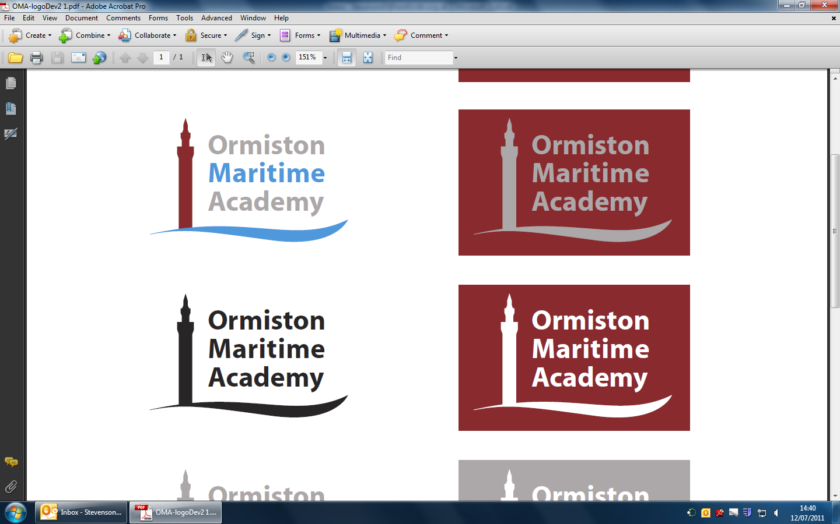

**Westward Ho, Grimsby, DN34 5AH**

**Tel: 01472 310015**

**Email:** [**office@omacademy.co.uk**](mailto:office@omacademy.co.uk)

**Website: www.omacademy.co.uk**

|  |  |  |  |
| --- | --- | --- | --- |
| Subject: NCFE Level 1/2 Technical Award in Creative  **DESIGN AND PRODUCTION** | | | |
| Terms | **Topics covered** and **core knowledge and skills** | Links to careers | Links to the Knowledge organiser and other additional resources |
| Half term 1 | DESIGN AND PRODUCTION IN CONTEXT  **Design movements:**  **Arts and Crafts** (circa 1860–1915):  KEY SOCIAL FACTORS:  ▪ reaction to industrialisation  ▪ aimed to improve the quality of design  KEY FEATURES:  ▪ emphasis on nature as a starting point for ideas  ▪ often handmade, hand-crafted items which were labour intensive and expensive  ▪ wide range of materials (wood, metal, textiles, glass and ceramics)  KEY DESIGNERS:  ▪ William Morris  ▪ Charles Voysey  **Art Nouveau** (circa 1880–1914):  KEY SOCIAL FACTORS:  ▪ desire to create ‘new’ or modern design for all social classes  ▪ showcase art for everyday life  KEY FEATURES:  ▪ natural, organic shapes with floral and plant influences  ▪ use of modern materials (iron, glass, ceramics) with wood  ▪ asymmetrical or whiplash curved lines  o key designers:  ▪ Louis Comfort Tiffany  ▪ Charles Rennie Mackintosh  **Art Deco** (circa 1920–1940):  KEY SOCIAL FACTORS:  ▪ reaction to World War I  ▪ Greek, Egyptian and Aztec influences  KEY FEATURES:  ▪ geometric, angular shapes, flowing circles and curves  ▪ elegant, functional, and ultra-modern  KEY DESIGNERS:  ▪ Eileen Gray  ▪ René Lalique | <https://www.rya.org.uk/training/careers>  <https://www.indeed.com/career-advice/finding-a-job>    <https://www.stem.org.uk/resources/community/collection/458166/careers-fashion-and-textiles>    <https://www.drapersonline.com/news>    [https://theartcareerproject.com](https://theartcareerproject.com/fashion-careers/)    <https://www.velvetjobs.com/articles/insights> | **Knowledge Organisers:**  <https://maritime.rivoagency.com/admin/wp-content/uploads/sites/20/2022/10/DT-Art-Nouveau-KO1.pdf>  <https://maritime.rivoagency.com/admin/wp-content/uploads/sites/20/2022/10/DT-Arts-Crafts-KO.pdf> |
|  | **Design principles:**  **Dieter Rams 10 good principles of design:**  *• is innovative*  *• makes a product useful*  *• is aesthetic*  *• makes a product understandable*  *• is unobtrusive*  *• is honest*  *• is long-lasting*  *• is thorough down to the last detail*  *• is environmentally friendly*  *• is as little design as possible* |  |  |
| Half term 2 | DESIGN AND PRODUCTION IN CONTEXT  **Design movements:**  **Bauhaus** (circa 1919–1933):  KEY SOCIAL FACTORS:  ▪ aesthetics of fine art applied to everyday items  ▪ function over decoration  KEY FEATURES:  ▪ streamlined design with little or no embellishment or ornamentation  ▪ mass production, use of industrial materials  KEY DESIGNERS:  ▪ Marcel Breuer  ▪ Marianne Brandt  **Modernism** (circa1914-1939):  KEY SOCIAL FACTORS:  ▪ social improvement through functionality and good design  ▪ rapid development of cities and modern industrial societies  KEY FEATURES:  ▪ experimentation with new and old technologies  ▪ adoption of technology in daily life  KEY DESIGNERS:  ▪ Ludwig Miles van der Rohe  ▪ Alvar Aalto  **Memphis** (circa 1981–1988):  KEY SOCIAL FACTORS:  ▪ Italian design group described as kitsch, garish and retro  ▪ reaction to the design of the 1970s and dominated the 1980s  KEY FEATURES:  ▪ bold, colourful, unusual pieces  ▪ block use of colour, white space  ▪ distinctive black lines and repetitive geometric patterns  KEY DESIGNERS:  ▪ Ettore Sottsass  ▪ Nathalie du Pasquier  **Post-modernism** (1945–late 20th century):  KEY SOCIAL FACTORS:  ▪ a broad movement, celebrates the unconventional  ▪ a pick-and-mix culture, no single definition of style  KEY FEATURES:  ▪ links to retro, techno punk and grunge  ▪ ridicules convention  KEY DESIGNERS:  ▪ Alberto Alessi  ▪ Vivienne Westwood  **Design principles:**  **How good design influences everyday life:**  ▪ *architecture*  *▪ fashion*  *▪ product design*  *▪ furniture*  *▪ sustainable design* |