### Y8 Geography Knowledge Organiser What on earth is Africa like?

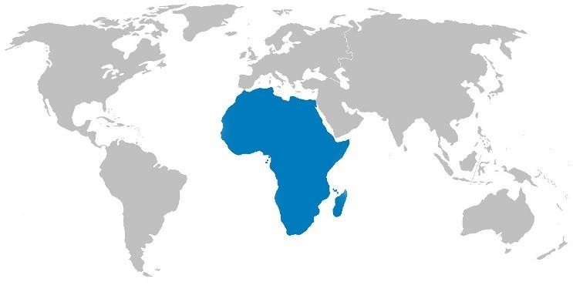Africa is one of the 7 continents of the world, it is the second largest and second most populous continent. The continent is surrounded by the Mediterranean Sea to the north, both the Suez Canal and the Red Sea along the Sinai Peninsula to the northeast, the Indian Ocean to the southeast, and the Atlantic Ocean to the west. The continent includes Madagascar. The continent of Africa, contains 54 countries. Africa hosts a large diversity of ethnicities, cultures and languages. In the late 19th century European countries colonised most of Africa, and were made independent in the 20th century. Before colonial rule Africa comprised up to 10,000 different states and autonomous groups with distinct languages and customs.

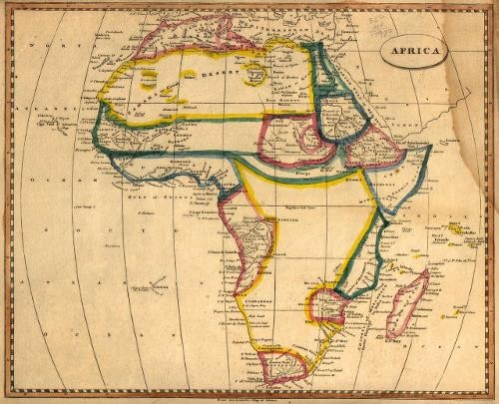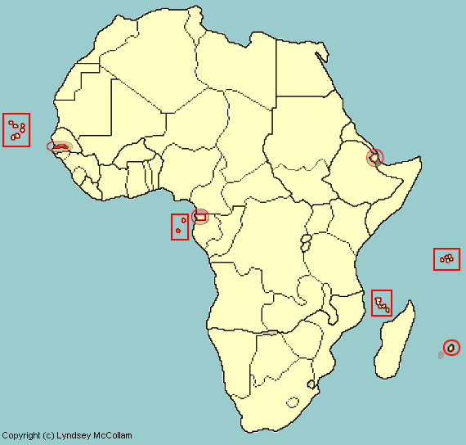

* Africa's highest point is Mt Kilimanjaro in Tanzania
* Africa's lowest point is Lake Assal in Djibouti
* The Second Congo War claimed over 5.4 million lives and is the deadliest worldwide conflict since World War II.
* Africa’s largest waterfall is called Victoria Falls, it is also referred to locally as the “Smoke that Thunders”. It is in southern Africa on the on the Zambezi River at the border of Zambia and Zimbabwe.
* Africa’s largest island is Madagascar, which is home to the lemur. Its people are incredibly diverse, its population is estimated at just over 22 million,

90% of whom live on less than $2 per day.

* Nigeria is fourth largest oil exporter in the world, and Africa’s biggest oil producer

**Physical Geography**

The Nile is a north-flowing river considered the longest river in the world at 6,650 km long. It is shared by and benefits eleven countries. The Sahara Desert, is the world's hottest desert, the third largest desert after Antarctica and the Arctic, and almost as large as China. Covering almost one-third of the continent, the Sahara is the largest hot desert in the world. The south of the Sahara is referred to as the Sahel region.

The northern half of the continent is primarily desert, or arid, while its central and southern areas contain both savanna plains and

dense jungle (rainforest) regions. Africa is the hottest continent on earth and 60% of the entire land surface consists of drylands and deserts.

The continents has the world's largest combination of density wild animal populations such as lions, cheetahs, buffalo, elephants, camels, and giraffes. Away from the savannah plains in the central rainforests include lowland and mountain gorillas, and many other types of primates However, many of these animals are under threat from poaching. Such as the pangolin which is the worlds most trafficked animal.

**Human Geography**

Although, Africa has abundant natural resources (Gold, Diamonds, and uranium), Africa remains the world's poorest and most underdeveloped continent. Water scarcity impacts the lives of over 300 million Africans, of whom approximately 75% of Africans rely on groundwater as their primary source of drinking water. Global warming is aggravating the situation.

### Y8 Geography Knowledge Organiser: Will Africa always be poor?

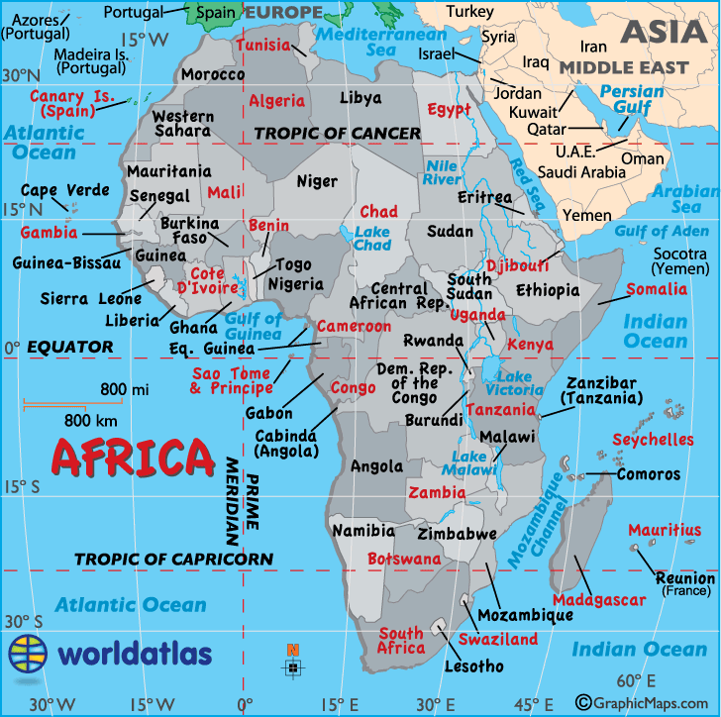

**Y8 Geography Knowledge Organiser: Measuring development (Africa and Development)**

**KPI Name:** To know what development is and know different ways to measure development.

Development:

* Development in geography is defined as **the continued improvement in quality of life**.
* Countries can be classified as either **high income countries (HIC)** or **low income countries** (LIC).
* Countries going through the transition between LIC to HIC are called Newly Industrialised Countries.
* Quality of life is often defined as “**health, wealth and education**”. However, measuring development is complicated.
* While we can use measures of development to class a country into HIC or LIC, however it should be noted that there is disparity (differences) within a country.

### Measuring Development: Single Indicators

* **There is no single way to measure development**. There are a number of different **social and economic development indicators** which can be used.
* Some examples include:
  + **GDP** (gross domestic product), the total value of goods and services produced by a country per year. (This can be divided per number of people in the country to make the GDP **per capita.**)
  + **Birth rate** per 1000 people
  + **Infant mortality** (infant deaths) per 1000 live births
  + **% adult literacy** (over 15s who can read and write)

### Life expectancy

* + **Years in education**

**Measuring Development: Composite Indicators**

* The UN has developed the HDI, the **human development index. HDI measure Quality of Life**
* It measures development according to three factors and then ranks the countries.

### Key words and terms:

**Development:**

The continued improvement in the quality of life of a country.

### Economic:

Anything to do with money or which affects the ability of people or a country to make money.

### Social:

Anything which affects people and families.

### Infant Mortality:

The death of children under the age of one year.

### Life expectancy:

The average age which a person is expected to life to.

### GDP:

The total value of goods and services produced by a country per year.

**Per capita:** Per person.

* These factors are **health** (life expectancy), **education ( adult literacy rate**) and **wealth** GDP per capita PPP (adjusted according to how much a dollar would buy in different countries).
* The number produced for the HDI is between 0- 1 (0 being the lowest score, and being close to 1 is a high value, which indicates high development
* In 2015 Norway in Europe was considered the highest on the index and Niger in Africa was the lowest. The UK was 14th.

An alternative to HDI: Bhutan, a country in central Asia, has an alternative method of measuring development. They measure the **“Gross**

**National Happiness”** (GNH) of their citizens. This measure focuses on the spiritual, physical, social and environmental health of its citizens.

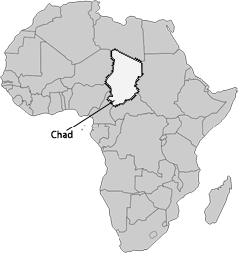

**Y8 Geography Knowledge Organiser: Factors affecting development (Africa and Development)**

|  |  |  |  |
| --- | --- | --- | --- |
| **KPI Name:** I know what development is and I know different ways to measure development. | | | **Key words and terms:**  **Economic:**  Anything to do with money or which affects the ability of people or a country to make money.  **Social:**  Anything which affects people and  families.  **Environmental:**  Anything relating to the physical geography of a country.  **Political:**  Anything to do with who controls the country or how it is run.  **Corrupt:**  When people or a government act dishonestly.  **Colony:**  A country which is controlled by another country.  **Investment:**  Putting money into a business or organisation to help it develop.  **Landlocked:**  When a country is entirely surrounded by land. |
| Factors affecting development:   * There are a number of different factors which can hinder a country’s development. * These factors can allow countries to develop more quickly or they can slow development. Some work together and some are more influential than others. | | |
|  | | |
| Economic factors:   * The products countries sell (these may not   earn much money on the global market)   * Businesses which are willing to invest in the country. * International debt | Environmental factors:   * The climate of a country * Natural disasters * Being landlocked (as this limits trade and access to technology) * The abundance or lack of natural resources | |
| Social factors:   * Lack of investment in education * Poor access to safe water (causing illness) * Lack of investment in healthcare * High dependency ratio (the balance of the number of working age people and those dependent on them). | Political factors:   * Conflict or civil war * A poor or corrupt government which is   unable or unwilling to invest   * Countries which used to be colonies for other countries (this historically limited their development, causing their   development to be delayed) | |
| Case study: Chad   * Chad is a LDC in central Africa. There are a number of factors which limit its development. * Chad has very few **doctors** for its population. This severely limits people’s access to healthcare. * Although the government in Chad is working to improvde **education**, the quality of education across the country varies widely. * Chad’s infrastructure is extremely limited. This is particularly evident in the **lack of roads** in Chad and the fact that very few people in Chad had access to **electricity**. | |  |