**Y8 Geography Knowledge Organiser: The Unstable Earth (The Earth’s Structure)**

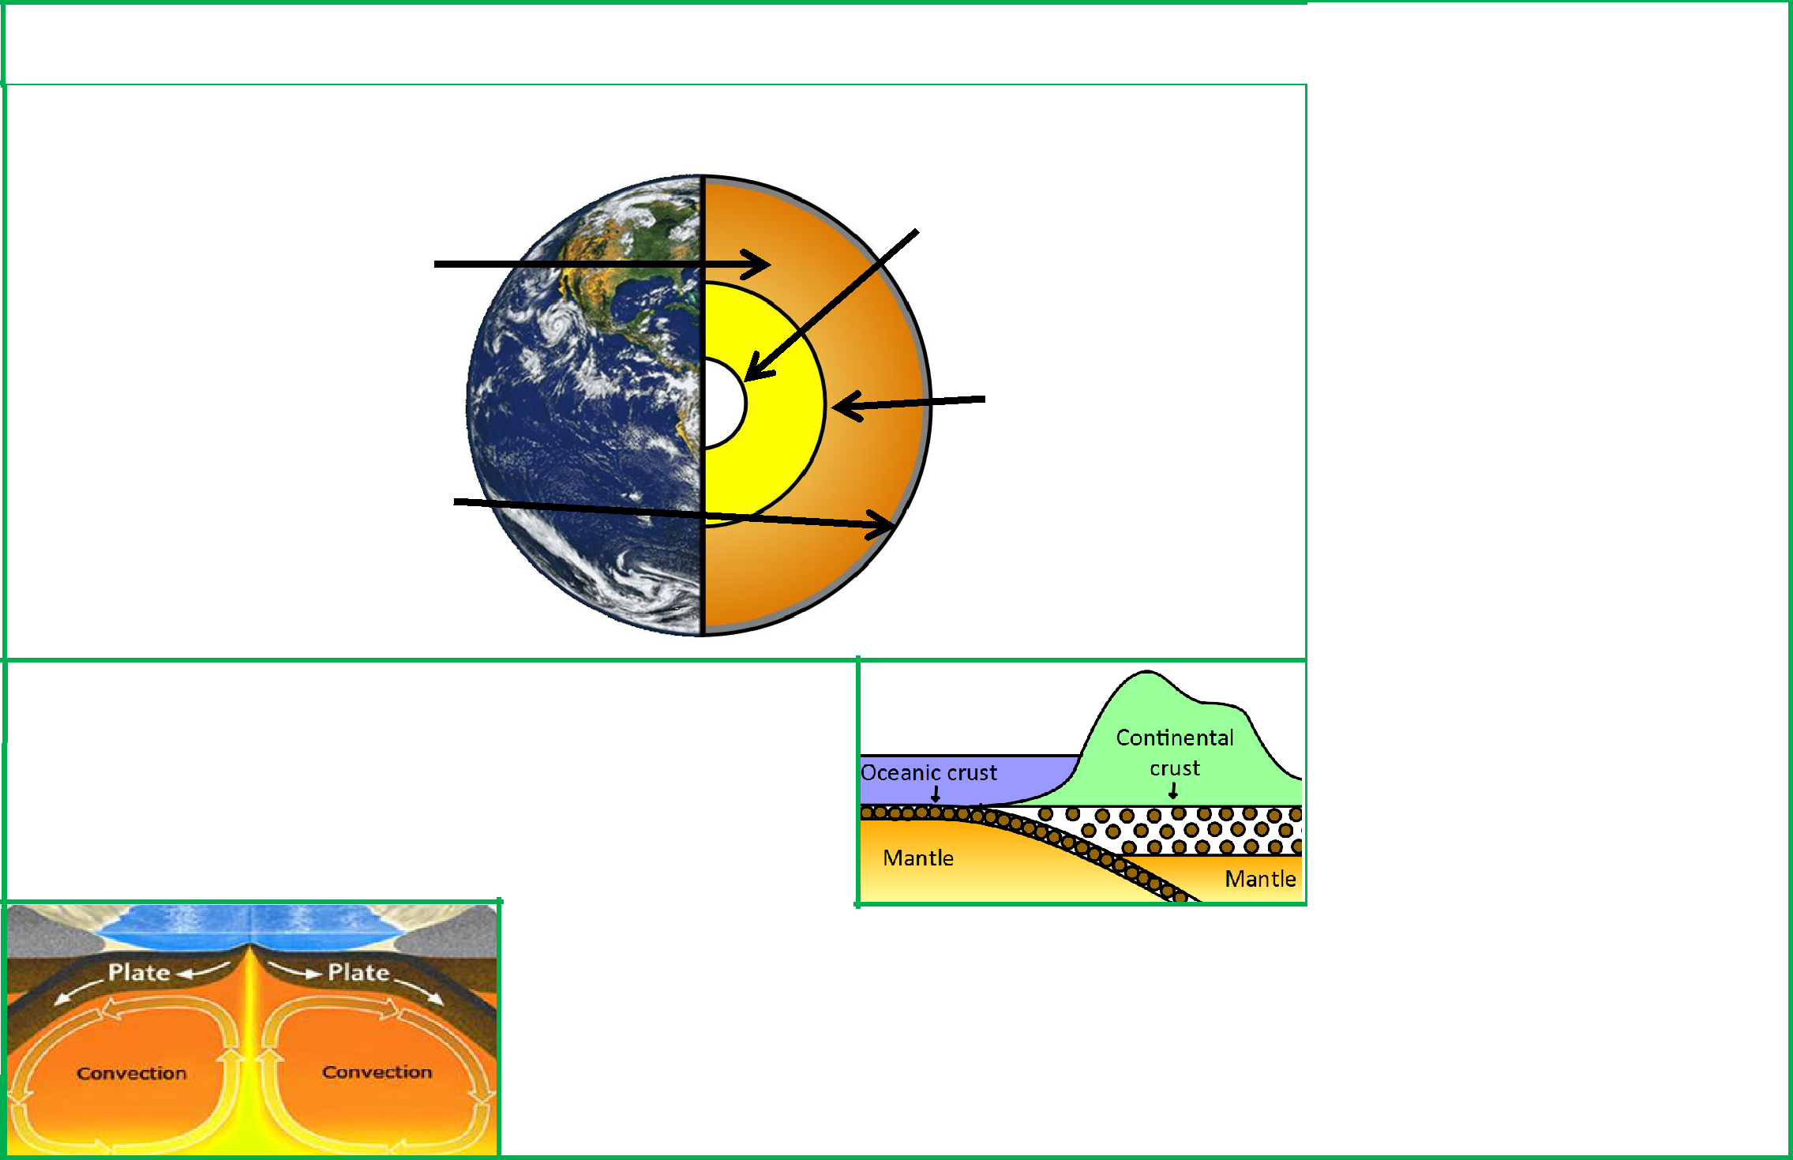

**KPI Name:**

To know the structure of the earth and to know why its unstable

**The earth’s structure:**

The Earth has four main layers : the **inner core**, the **outer core**, the **mantle** and the **crust**.

**Key words and terms:**

**Crust:**

The rocky outer layer of the earth, made up of oceanic and continental crust.

The mantle is semi-molten and about 3,000 km thick. The closer the mantle is to the core, the more liquid it is.

The crust is the rocky outer layer. It is thin compared to the other sections, approximately 5 to 70 km thick. If the Earth was scaled down to the size of an apple, the crust would be about the thickness of the apple skin.

The inner core is extremely hot (5,500°C ). It is a very dense solid made from iron and nickel.

The outer core is 2,000 km thick and is a liquid.

**Mantle:**

Semi-molten rock, moving beneath the earth’s crust. It is the movement (convection currents) in the mantle which cause tectonic plates to move

**Outer core:**

A 2000km thick liquid made up largely of iron and nickel.

**Inner Core:**

A dense solid of extreme temperature (5,500°C) made up of iron and nickel.

**Tectonic plates:**

**The earth’s crust:**

* The earth’s crust is broken up into plates, called tectonic plates.
* There are two types of tectonic plate oceanic and continental.
* Oceanic plates carry **the oceans**. They are **thinner** but **more dense** than continental plates.
* Continental plates carry **the land**. They are **thicker** but **less dense** than oceanic plates.
  + Heat from the core causes convection currents in the mantle. These cause the mantle to move as it heats and cools.
  + These currents slowly move the crust around.
  + In some places the crust is destroyed. In other places new crust is formed.

Huge plates (oceanic and continental) that make up the earth’s crust, and which move because of convection currents.

**Convection currents:**

Currents in the mantle which cause the tectonic plates to move, caused by

extreme heat from the earth’s core.

**Dense:**

When something is closely packed together.

**Molten:**

Something which is melted and has become a liquid.

**Geography Knowledge Organiser 8.1.2: The Unstable Earth (Plate boundaries)**

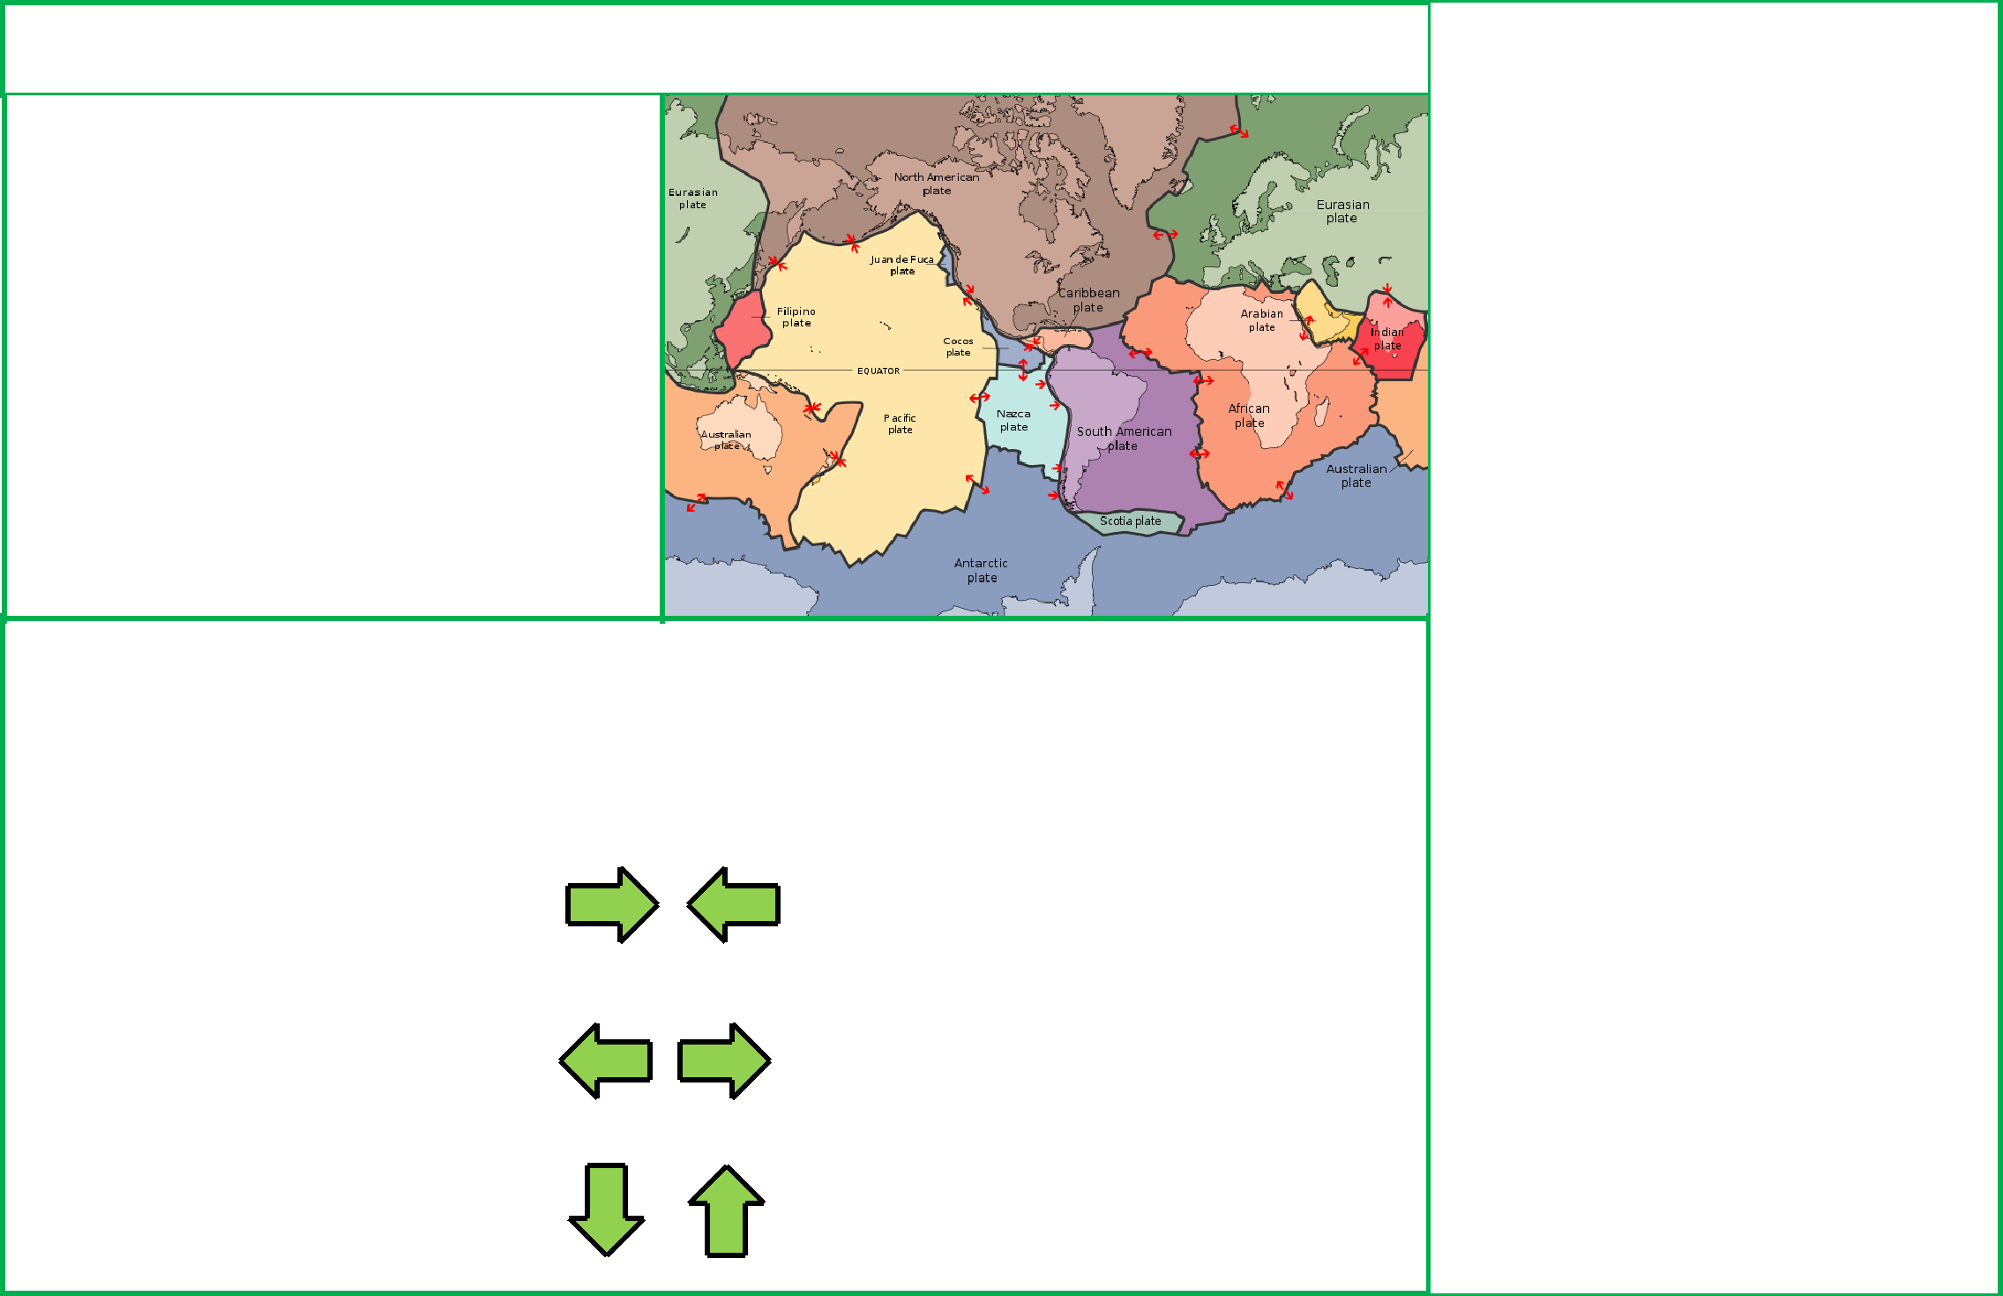

**KPI Name:**

To describe conservative, constructive and destructive plate boundaries.

**Plate boundaries:**

* The Earth’s crust is broken into different plates, which sit on the Earth’s mantle.
* These plates move because of **convection** **currents**.
* The plates move in different directions and meet at **plate boundaries**.
* As the plates move, parts of the crust are **destroyed** and in other areas new crust is **created**.

**Different types of plate boundary:**

* There are three different types of plate boundary: **destructive**, **constructive** and **conservative**. Which type they are depends on how the plates move at this boundary.
* Different plates boundaries have different landforms, such as volcanoes and fold mountains.

|  |  |  |  |  |
| --- | --- | --- | --- | --- |
| **Boundary** | **Movement** | **Diagram** | **Example** | **Landforms** |
|  |  |  |  |  |
| Destructive | The plates either |  | The Nazca plate being | Volcanoes |
|  | **collide** or the oceanic |  | forced under the | Fold mountains |
|  | plate **subducts under** |  | South American plate. | Earthquakes |
|  | the continential plate. |  |  |  |
|  |  |  |  |  |
| Constructive | The plates **move** |  | The African plate and | Volcanoes |
|  | **apart.** |  | the South American |  |
|  |  |  | plate. |  |
|  |  |  |  |  |
| Conservative | The plates move |  | The Pacific plate and | Earthquakes |
|  | **alongside** each other. |  | the North American |  |
|  |  |  | plate. |  |
|  |  |  |  |  |

**Key words and terms:**

**Plate boundaries:**

Where two or more tectonic plates meet.

**Conservative:**

A plate boundary where two plates slide past one another.

**Constructive:**

A plate boundary where two plates are moving apart.

**Destructive:**

A plate boundary where two plates are colliding.

**Magma:**

Molten rock from the mantle before it reaches the surface of the earth.

**Lava:**

Molten rock released from the earth’s core by a volcano.

**Fold Mountains:**

Mountains formed at collision zones, where two continental plates move towards each other.

**Volcano:**

A vent in the earth’s crust from which lava, ash and gas is released.

**Earthquake:**

A sudden shaking of the ground, caused by movement in the earth’s crust.

**Geography Knowledge Organiser 8.1.3: The Unstable Earth (Composite and shield volcanoes)**

**KPI Name:**

To describe conservative, constructive and destructive plate boundaries.

**Volcanoes:**

* Volcanoes are a vent in the earth’s crust from which lava, ash and gas is released.
* Most volcanoes form at **destructive and constructive** plate boundaries.
* Volcanoes **do not form at conservative boudaries**.
* If a volcano forms at a plate boundary, they are either **composite** or **shield** volcanoes.
* Of these two types, volcanoes can be **active**, **dormant** or **extinct.**

**Composite and shield volcanoes:**

There are a number of key differences between composite and shield volcanoes.

|  |  |  |
| --- | --- | --- |
|  | **Composite** | **Shield** |
|  |  |  |
| **Diagram** |  |  |
|  |  |  |
| **Shape** | Steep sides. | Gentle sides. |
|  |  |  |
| **Plate** | Form at **destructive** plate boundaries. | Form at **constructive** plate boundaries. |
| **boundary** |  |  |
|  |  |  |
| **Lava** | Thick lava. | Thin, runny lava. |
|  |  |  |
| **Eruptions** | Eruptions happen **less often** but are usually | Eruptions happen **often** but they are usually |
|  | **violent**. The eruption consists of **ash,** | quite **gentle**. The eruption is mainly **lava**, with |
|  | **pyroclastic flow and lava**. | little **pyroclastic flow.** |
|  |  |  |
| **Example** | Mount Vesuvius in Naples, Italy. | Mauna Loa in Hawaii. |
|  | Mount St. Helens, USA | La Cumbre, The Galapagos Islands |
|  |  |  |

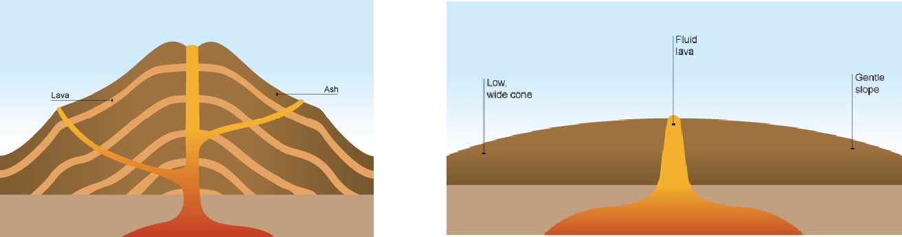

**Key words and terms:**

**Magma chamber:**

A large underground pool of magma.

**Lava:**

Magma, once it reaches the surface.

**Crater:**

A bowl-shaped basin in the top of the volcano.

**Vent:**

The central tube which magma travels through.

**Cone:**

A hill produced around a volcano by the eruption of lava and ash.

**Pyroclastic flow:**

A mass of hot ash, gases and lava fragments which is ejected from a volcano at great speeds.

**Active:**

Volcanoes which erupt frequently.

**Dormant:**

Volcanoes which have not recently erupted by which can still erupt.

**Extinct:**

A volcano which is unlikely to ever erupt again.

**Geography Knowledge Organiser 8.1.4: The Unstable Earth (The effects of a volcanic eruption and PPP)**

**KPI Name:**

To explain the effects of a volcanic eruption. To be able to describe a case study of a volcanic eruption.

**The effects of a volcanic eruption:**

* It is important to note that volcanic eruptions can have both **positive and negative effects**.
* These effects can also be grouped into economic, social and environmental effects.
* The extent of the negative effects on a country often depends on the ability of the country to **predict, prepare for and** **protect people from the eruption** (**PPP**).

|  |  |  |  |  |
| --- | --- | --- | --- | --- |
|  | **Positive:** | **Negative:** |  |  |
|  | The dramatic scenery created by volcanic eruptions attracts | Lives can be lost. | |  |
|  | tourists. This brings income to an area. |  |
|  |  |  |  |
|  | The lava and ash deposited during an eruption breaks down to | If the ash and mud from a volcanic eruption mix with rain | |  |
|  | provide valuable nutrients for the soil. This creates very fertile | water or melting snow, fast moving mudflows are created. | |  |
|  | soil which is good for agriculture | These flows are called lahars. |  |  |
|  | The high level of heat and activity close to a volcano can | Lava flows and lahars can destroy settlements and areas of | |  |
|  | provide opportunities for generating geothermal energy. | woodland or agriculture. | |  |
|  |  |  |  |  |

|  |  |  |  |  |
| --- | --- | --- | --- | --- |
| **Mount St. Helens, USA, 1980: (MDC)** |  | **Nyiragongo, Democratic Republic of Congo, 2002: (LDC)** |  |  |
| In 1980, Mount St. Helens, a composite volcano in a rural | | In 2002, Nyiragongo, a composite volcano near the of Goma | |  |
| area in the Northeast of the USA, erupted. | | in the DRC, erupted, causing lava to flow into its city centre. | |  |
|  |  |  |
| **Effects:** | | **Effects:** | |  |
| - Roughly 130,000 people were made homeless. | |  |
| - More then 200 homes were destroyed. | |  |
| - 300,000 people were evacuated from the area. | |  |
| - 57 died as a result of the eruption. | |  |
| - Approximately 100 people died as a result of the eruption. | |  |
| - 185 miles of roads and 15 miles of railways were | |  |
| - The lava destroyed roughly 80% of the city’s infrastructure | |  |
| damaged. | | (roads, electricity services, sewage pipes). | |  |
| - Damage to to property was estimated at $1.1 billion. | | - Cholera and other diseases spread as people did not have | |  |
|  |  | access to clean water. | |  |
| **Responses and PPP:** | | **Responses and PPP:** | |  |
| - Seismographs began closely monitoring the volcano | |  |
| - Due to unrest in the country, the volcano was not | |  |
| roughly 3 months before the eruption. | |  |
| properly monitored and the eruption was unexpected. | |  |
| - Hundreds of tourists and scientists flocked to the area. | |  |
| - There was no clear plan in place in case of an eruption. | |  |
| However, the government imposed an exclusion zone | |  |
| - A huge amount of foreign aid was sent to the DRC to help | |  |
| around the volcano to prevent loss of life. | |  |
| people cope. | |  |
| - The US government issued $950 million in emergency | | - It took years for Goma’s economy to recover, even with | |  |
| funds to help recovery efforts. | | the support of aid agencies. | |  |

**Key words and terms:**

**Economic:**

Anything to do with money or which affects the ability of people or a country to make money.

**Social:**

Anything which affects people and families.

**Envrionmental:**

Anything which affects animals, plants or ecosystems in the area.

**Prediction:**

Attempting to know when a volcanic eruption will happen. This can be done by measuring **earthquakes**, **gas levels** around thevolcano and the **temperatures** **around the volcano**.

**Preparation:**

Creating and communicating a plan to deal with a possible eruption. This could include creating an

**exclusion zone**, or making sure

people have access to **supplies**.

**Protection:**

Trying to reduce the damage people suffer during a volcanic eruption. This could include building houses in safe areas.

**Geography Knowledge Organiser 8.2.1: The Unstable Earth (Tectonic plate boundaries and earthquakes)**

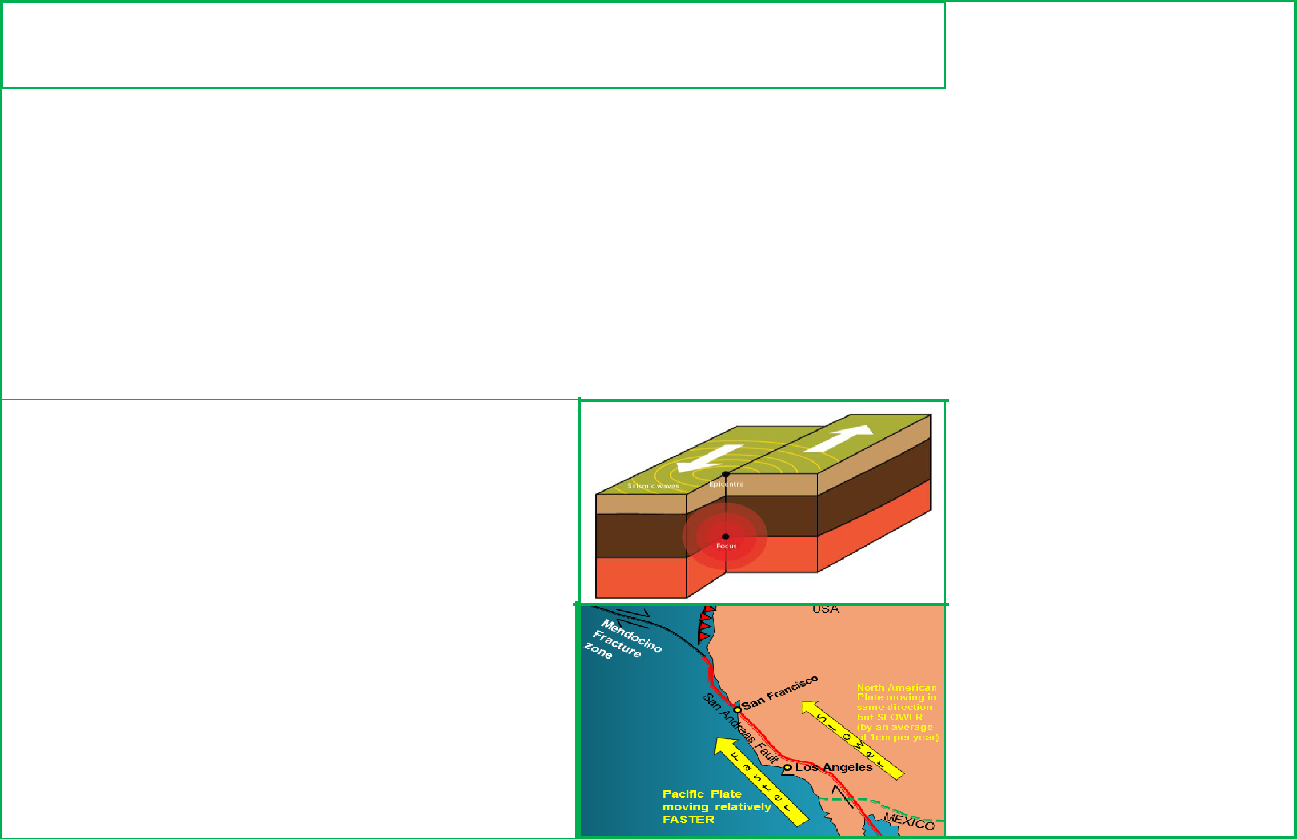

**KPI Name:**

I understand the three kinds of tectonic movement and how they link to earthquake activity, using key terminology.

**Plate boundaries and earthquakes:**

* The Earth’s crust is broken into different plates, which sit on the Earth’s mantle.
* The plates move in different directions and meet at **plate boundaries**. These three boundaries are called **destructive, constructive or conservative** plate boundaries (see knowledge organsier 8.1.2 for furtherdetail).
* Earthquakes can happen **at any plate boundary**.
* Plates do not always move smoothly alongside, under or beside each other. They sometimes get stuck. When this happens pressure builds up and, when this pressure is released, an earthquake occurs.
* Every earthquakes has an **epicentre** and a **focus**.
* The focus is the point in the earth’s crust where the pressure between the two plates is released. It is underground.
* The epicentre is the point on the **surface** of the crust, above the focus.

**Earthquakes on *conservative* plate boundaries:**

* Earthquakes can occur at all plate boundaries. However, conservative plate boundaries clearly show how earthquakes happen.
* The **San Andreas Fault** is part of the plate boundary between the **Pacific plate** and the **North American plate**.
* The Pacific plate moves slightly faster than the North American plate. This means that, even though the plates are moving in the same direction, they can get stuck, causing a build up of **pressure**.
* This build up and release of pressure caused two major earthquakes during the last century, in 1906 and in 1989.
* However, this area experiences constant small earthquakes, with Los Angeles experiencing 10 earthquakes per day on average!
* Because of this movement, Los Angeles should be in line with San Francisco in roughly 20 million years.

**Key words and terms:**

**Earthquake:**

The shaking or vibration of the earth’s crust due to pressure at a plate boundary.

**Mantle:**

The semi-molten layer below the earth’s crust.

**Crust:**

The thin, rocky outer layer of the earth. It is broken into many different plates.

**Plate boundary:**

The point where two tectonic plates meet.

**Destructive plate boundary:**

Where two plates meet and they are moving towards each other.

**Constructive plate boundary:** Where two plates meet and they are moving away from each other.

**Conservative plate boundary:** Where two plates meet and they are moving alongside each other (either in the same or opposite directions).

**Geography Knowledge Organiser 8.2.2: The Unstable Earth (Measuring and predicting earthquakes)**

**KPI Name:**

I can explain how earthquakes are predicted and measured.

**Predicting earthquakes:**

* Scientists can currently forcast the likelihood of an earthquake in the long term (over years and decades). However, it is almost impossible to predict earthquakes in the short term.
* However, there are ways that scientists can **monitor** tectonic activity to help them forcast earthquakes:
  + Scientists can look at the **history** of earthquakes in the area and try to identify patterns about them.
  + Some scientists argue that a **higher level of radon gas being released into the atmosphere** is a sign of an impending earthquake.
  + An increase in **minor earthquakes**, measured using a **seismometer**, often suggests an impending, larger earthquake.

**Measuring earthquakes:**

* Each year scientists record over 20,000 earthquakes. Most of these earthquakes are small and are not noticed by ordinary people.
* Earthquakes are measured according to two different scales: the **Richter scale** and the **Mercalli scale**.
* Some argue that the Mercalli scale is not as reliable as the Richter scale because it is **subjective** and can vary according to where you are.

**The Mercalli Scale (without the final 2 levels):**

|  |  |  |  |  |
| --- | --- | --- | --- | --- |
| **Intensity** | **Shaking** | **Description/Damage** |  |  |
| I | Not felt | Not felt except by a very few. |  |  |
| II | Weak | Felt only by a few persons at rest,especially on upper floors of buildings. |  |  |
| III | Weak | Felt quite noticeably by persons indoors, especially on upper floors of buildings. Many people do not recognize it |  |  |
| as an earthquake. Vibrations similar to the passing of a truck. |  |  |
|  |  |  |  |
|  |  |  |  |  |
| IV | Light | Felt indoors by many, outdoors by few during the day. At night, some awakened. Dishes, windows and doors |  |  |
| disturbed; walls make cracking sound. Sensation like heavy truck striking building. Standing motor cars rocked. |  |  |
|  |  |  |  |
|  |  |  |  |  |
| V | Moderate | Felt by nearly everyone; many awakened. Some windows broken. Unstable objects overturned. |  |  |
|  |  |  |  |  |
| VI | Strong | Felt by all, many frightened. Some heavy furniture moved. Damage slight. |  |  |
|  |  |  |  |  |
| VII | Very strong | Slight damage in buildings of good design and construction; moderate in well-built ordinary structures; |  |  |
| considerable damage in poorly built structures. |  |  |
|  |  |  |  |  |
| VIII | Severe | Damage slight in specially designed structures; considerable damage in ordinary substantial buildings with partial |  |  |
| collapse. Damage great in poorly built structures. Fall of chimneys, factory stacks, columns, monuments. |  |  |
|  |  |  |  |
|  |  |  |  |  |
| IX | Violent | Damage considerable in specially designed structures. Damage great in substantial buildings, with partial collapse. |  |  |
| Buildings shifted off foundations. |  |  |
|  |  |  |  |
| X | Extreme | Some well-built wooden structures destroyed; most masonry and frame structures destroyed with foundations. |  |  |
| Rails bent. |  |  |
|  |  |  |  |
|  |  |  |  |  |

**Key words and terms:**

**Seismometer:**

A machine which detects and records vibrations in the earth’s crust.

**Richter Scale:**

A scale which is used to measure the strength of earthquakes. It uses the strength of vibrations to class earthquakes between 1 and 10.

**Mercalli Scale:**

A scale which is used to measure the damage of earthquakes. It uses the damage caused to class earthquakes between 1 and 12.

**Subjective:**

Something which changes according to people’s perceptions or opinions.

**The Richter Scale:**

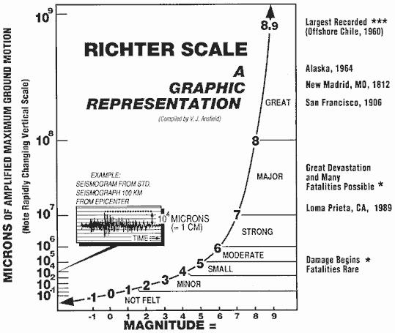

**Geography Knowledge Organiser 8.2.3: The Unstable Earth (The effects of an earthquakes and PPP)**

**KPI Name:**

I can demonstrate how the impact of an earthquake in an MDC or LDC is influenced by the extent of prediction, preparation and response.

**The effects of an earthquake:**

The damage of an earthquakedepends on the ability of the country to **predict, prepare for and protect people from the effects** **of the earthquake** (**PPP**).

|  |  |  |  |
| --- | --- | --- | --- |
|  | **Social Impacts** | **Economic Impacts** | **Environmental impacts** |
|  |  |  |  |
| **Short** | People may be killed or injured. Homes | Shops and business may be | The landscape may be destroyed |
| **Term:** | may be destroyed. Infrstructure may be | destroyed. Looting may take place. | because of fires or landslides |
|  | disrupted. Water supplies may be |  | Tsunamis may cause flooding in |
|  | contaminated. |  | coastal areas. |
|  |  |  |  |
| **Long** | Disease may spread. People may have | Rebuilding can be expensive. Income | Important natural and human |
| **Term:** | to be re-housed, sometimes in refugee | could be lost. | landmarks may be lost. |
|  | camps. |  |  |
|  |  |  |  |

|  |  |  |  |
| --- | --- | --- | --- |
| **Chile, 2010: (MDC)** |  | **Haiti, 2010: (LDC)** | |
|  |  |  |  |
| In 2010, Chile experienced an earthquake measuring 8.8 on the | | In 2010, Haiti experienced an earthquake measuring 7.0 on | |
| richter scale originating from the boundary between the South | | the richter scale originating from the boundary between the | |
| American and Nazca plates. | | Caribbean and North American plates. | |

|  |  |
| --- | --- |
| **Effects:** | **Effects:** |
| - 500 people died. | - 220,000 people died. |
| - 500,000 buildings were destroyed, including minor damage | - 1 million people were made homeless and the main port, |
| to a major airport. | airport and roads were severely damaged. |
| - Communication networks and power went down after the | - 2 million people had no food or clean water. |
| earthquake. | - Many homes and businesses were looted because of a |
|  | lack of government presence. |
| **Responses and PPP:** |  |
| - Chile has a history of earthquakes, meaning that most | **Responses and PPP:** |
| buildings were ‘earthquake proof’ and people were trained | - Haiti has no history of earthquakes. As a result, their |
| in how to survive earthquakes. | buildings were not prepared and people were not drilled. |
| - Within 10 days power was restored to affected areas. | - Other countries, such as the USA, sent aid to help. |
| - Roads were repaired very quickly. | However, the damaged airport found it difficult to cope. |
| - Chile put in place a house rebuilding scheme which was paid | - Due to a weak and poor government people are still |
| for by the Chilean government. | living in camps almost 10 years after the earthquake. |

**Key words and terms:**

**Infrastructure:**

The basic physical facilities in an area, such as electricity, running water, roads and buildings such as hospitals.

**Aid:**

Money or resources which is given to a country by another country or an organisation.

**Prediction:**

Attempting to know when an earthquake will happen. This can be done by measuring **vibrations** **in the crust** and by **studying previous major earthquakes**.

**Preparation:**

Creating and communicating a plan to deal with a possible earthquake. This could include creating an **exclusion zone**, or making sure people have access to **supplies**.

**Protection:**

Trying to reduce the damage people suffer during an earthquake. This could include building houses in safe areas.