Contemporary  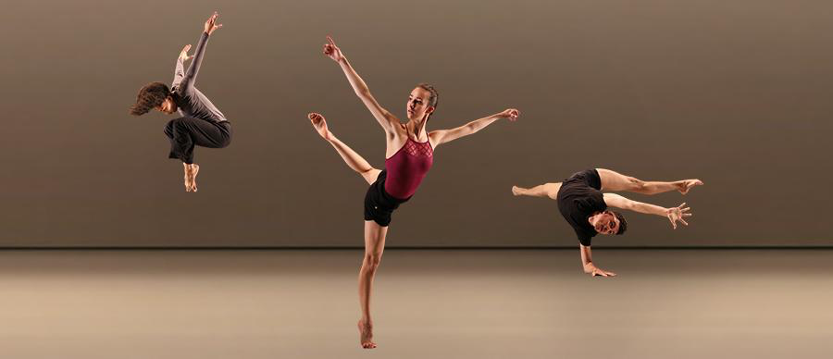  What is contemporary dance?  Contemporary is a style of expressive dance that combines elements of dance styles/techniques, allowing for expression, interpretation and emotional responses.  This style developed at the start of the 20th century in America, but is influenced from styles across the world.  What are the key features of this style?  Within the contemporary style, the main features consist of contact and release, floor work, fall and recovery and improvisation.  In this style, bare flexed feet are prominent and contemporary choreography encourages a performer to explore various lines and shapes with their body and methods of travelling. | Key Vocabulary and Terms:  Accuracy  The ability to perform given movements with precision  Artistic Intention  What the choreographer intends to communicate through the choreography to the audience/viewer  Focus  Where the dancer is looking or facing during a performance  Motif  A short sequence of movement (usually 8-16 counts)  Key Features:  Contractions, releases, tilts, rolls, turns, jumps, lunges,  falls, shift of body weight, change of direction, use of levels. | 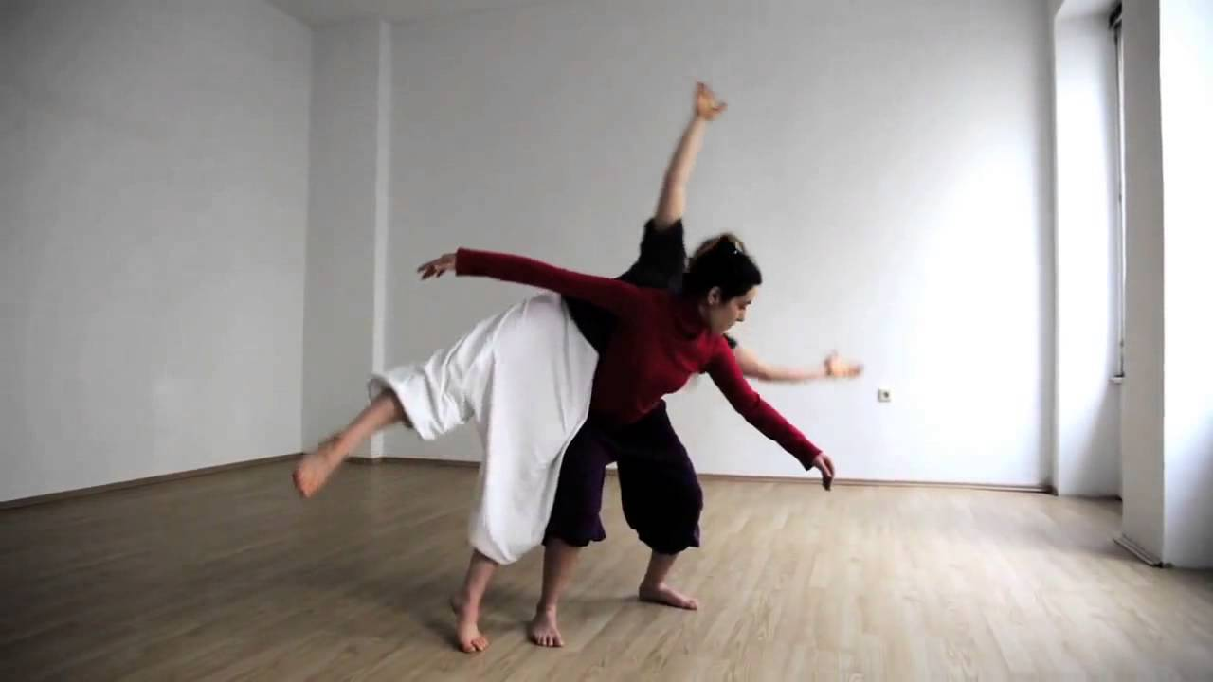  Improvisation  Improvisation is a technique used  in contemporary dance. The focus is mainly on the relationship between movements and performance and encourages a performer to explore.  Improvisation is a very personal technique as it is formed through the ideas, feelings and creativity of the individual.  Key Features:  - Use of space and floor  - Exploring ways of moving body parts  - Emotion and expression  Steve Paxton is a choreographer who focuses on a technique called contact improvisation. This can be a duet dance characterized by fluid movement, weight exchange, and touch. Partners improvise the dance using the natural movement of the body.
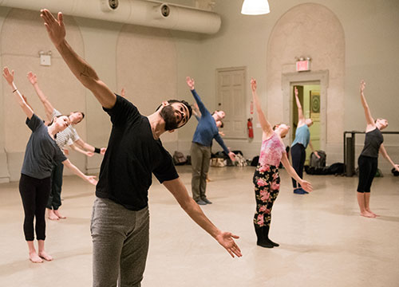  Contraction & Release  Martha Graham developed a technique called ‘contraction and release’. Graham is known for being a pioneer in contemporary dance and this technique is used frequently in modern choreography.  Contraction and release uses different parts of the body in opposition to one another to create spirals for dramatic tension. It also incorporates formal exaggerations of "natural" movements  Key Features:  - Spirals  - Exaggerated movement  - Contrast in pace  - Floor work | 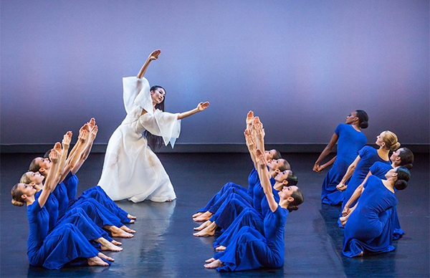  Fall & Recovery  Doris Humphrey developed a technique called ‘fall and recovery’ which focuses on balance and how a body responds to gravity. Humphrey’s technique is also thought to be one of the first traditional techniques that is still used in modern contemporary choreography.  This technique requires a performer to explore levels, high releases, tipping in and out of movements and suspension.  Key Features:  - Drop Swings  - Contrast in speed  - Relationship between levels and momentum | 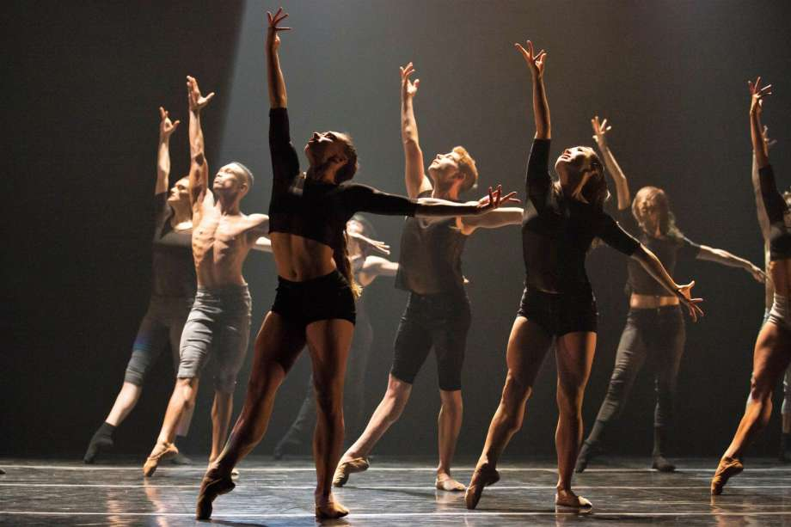  Lyrical  Lyrical is a form of contemporary  dance that combines ballet and jazz.  However, unlike the traditional technique of ballet and jazz, lyrical allows a performer to add their own personal style and expression and combine movements together.  Key Features:  - Expressive  - Communicating a story, theme or emotion  - Interpretation  - Combination of ballet, jazz and traditional contemporary

