**Food labelling and health claims**

**Date marks**

**Best-before-date**:The date after which foods may not be at their best, although probably safe to eat if stored according to instructions.

**Use-by-date:** The date given to foods that spoil quickly, such as cooked meats. It is unsafe to eat foods beyond their use-by-date.

**Legally required information**

* Name of food or drink.
* List of ingredients (including water and food additives), in descending order of weight.
* Weight or volume.
* Date mark (Best-before and use-by).
* Storage and preparation conditions.
* Name and address of the manufacturer, packer or seller.
* Country of origin and place of provenance.
* Nutrition information.

Additional information may also be provided, such as cooking instructions, serving suggestions or price.

**Additives**

Food additives must be shown clearly in the list of ingredients on food labels, either by the additive’s name or E number.

Additives are added to ensure safety, increase shelf life or improve the taste, texture or appearance of food. Additives need to be approved before they can be used. Additives are given an ‘E number’ to show that they have been rigorously tested for safety and have been approved for use in food by the European Commission.

An example is E100 or curcumin, made from turmeric.

**Food labelling**

Manufacturers include a range of information on food labels. Some of which is legally required and some of which is useful to the consumer or supermarket.

Nutrition information helps consumers make healthier choices. Back-of-pack nutrition information is legally required on food packaging.

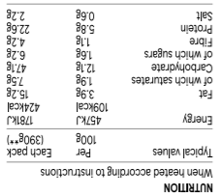

**Key terms**

**Additives:** Are added to ensure safety, increase shelf life or improve the taste, texture of appearance of food. They must be shown clearly on food labels.

**Allergen labelling:** Allergens must be clearly shown in **bold**, highlighted, underlined or in *italics*.

**Back-of-pack labelling**: Is legally required and can help consumers make healthier choices.

**Claim:** Any statement about the nutrient content or health benefit of a food product.

**Front-of-pack labelling**: Is voluntary but must provide certain information and can use red, amber and green colour coding.

**Labelling:** The term given to the information about the product which is displayed on the packaging.

**Nutrition information:** Helps consumers make healthier choices.

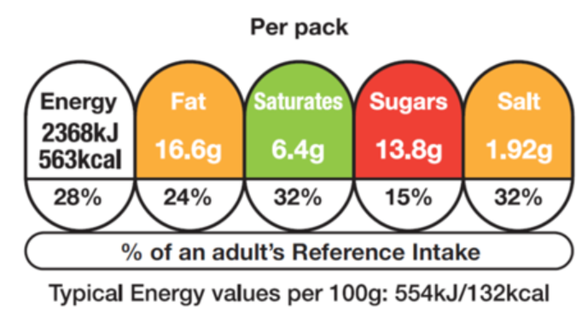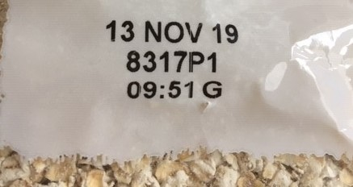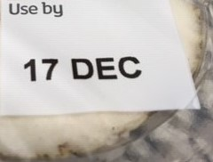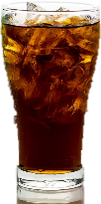

**Tasks**

1. Find four different packaged food items in your household or online and list the information provided on the packaging. Explain the purpose of each piece of information and identify if it is legally required or consumer information.
2. Explain the importance of date marks and storage instructions, including the consequences of not following them.

**Nutrition and health claims**

Nutrition and health claims are controlled by European regulations. Claims on a food or drink should have been authorised and listed on the European register of claims and have met certain conditions.

**Nutrition claims**

A nutrition claim describes what a food contains (or does not contain) or contains in reduced or increased amounts. Examples include:

* Low fat (less than 3g of fat per 100g of food);
* High fibre (at least 6g of fibre per 100g of food);
* Source of vitamin C (at least 15% of the nutrient reference value for vitamin C per 100g of food).

**Health claims**

A health claimstates or suggests there is a relationship between a product and health. In order to make a claim, the amount present of the nutrient, substance or food must fulfil the specific conditions of use of the claim. The types of health claims are:

* 'Function Health Claims’;
* 'Risk Reduction Claims';
* Health 'Claims referring to children's development'.

Another example is caramel (E150), a synthetic colouring commonly used to colour colas.

**Beetroot salad**

Keep refrigerated. Once opened consume within 24 hours and by the ‘use-by’ date shown.

Milk

Molluscs

Mustard

Nuts

Peanuts

Sesame

Soybeans

Sulphur dioxide

Celery (and celeriac)

Cereals containing gluten

Crustaceans

Eggs

Fish

Lupin

|  |
| --- |
| INGREDIENTS |
| Water, Carrots, Onions, Red Lentils (4.5%), Potatoes, Cauliflower, Leeks, Peas, Cornflour, **Wheat** flour, Cream (**milk**), Yeast Extract, Concentrated Tomato Paste, Garlic, Sugar, **Celery** Seed, Sunflower Oil, Herb and Spice, White Pepper, Parsley |
| ALLERGY ADVICE |
| For allergens, see ingredients in **bold** |

**Allergen labelling**

An allergic reaction to a food can be described as an inappropriate reaction by the body's immune system to the ingestion of a food.

By law, food, drink and ingredients that are known to contain allergens are required to be in **bold**, highlighted, underlined or in *italics*.

The most common allergens are present in:

**Front-of-pack labelling**

Front-of pack-nutrition information is voluntary but if a food business chooses to provide this, only the following information may be provided:

* energy only;
* energy along with fat, saturates, sugar and salt.

Red, amber and green colours, if used, show at a glance whether a food is high, medium or low for fat, saturates, sugars or salt. The colour coding can be used to compare two products.

|  |  |  |  |  |
| --- | --- | --- | --- | --- |
| **Nutrient** | **Low** | **Medium** | **High** |  |
| Fat | ≤3.0g/100g | >3.0g to ≤ 17.5g/100g | >17.5g/100g | >21g/portion |
| Saturates | ≤1.5g/100g | >1.5g to ≤5.0g/100g | >5.0g/100g | >6.0g/portion |
| (Total sugars) | ≤5.0g/100g | >5.0g and ≤22.5g/ 100g | >22.5g/100g | >27g/portion |
| Salt | ≤0.3g/100g | >0.3g to ≤1.5g/100g | >1.5g/100g | >1.8g/portion |

To find out more, go to: <https://bit.ly/2SPnj1g>

Note: Portion size criteria apply to portion sizes/servings greater than 100g.