**Cooking**

* A broad range of ingredients, equipment, food skills and techniques, and cooking methods are used to achieve successful results.
* Recipes and cooking methods can be modified to help meet current healthy eating messages.

**Key terms**

**Conduction:**The exchange of heat by direct contact with foods on a surface e.g. stir-frying or plate freezing.

**Convection:**The exchange of heat by the application of a gas or liquid current e.g. boiling potatoes or blast chilling.

**Heat** **transfer**: Transference of heat energy between objects.

**Radiation**: Radiation is energy in the form of rays, e.g. grilling.

**Heat exchange/transfer**

Cooking requires heat energy to be transferred from the heat source, e.g. the cooker hob, to the food. This is called heat transfer or heat exchange. There are three ways that heat is transferred to the food.

They are:

* conduction – direct contact with food on a surface, e.g. stir-frying;
* convection - currents of hot air or hot liquid transfer the heat energy to the food, e.g. baking;
* radiation - energy in the form of rays, e.g. grilling.

Many methods of cooking use a combination of these. The amount of heat and cooking time will vary according to the type of food being cooked and the method being used.

**Food skills are acquired, developed and secured over time.**

**Bridge hold Claw grip**

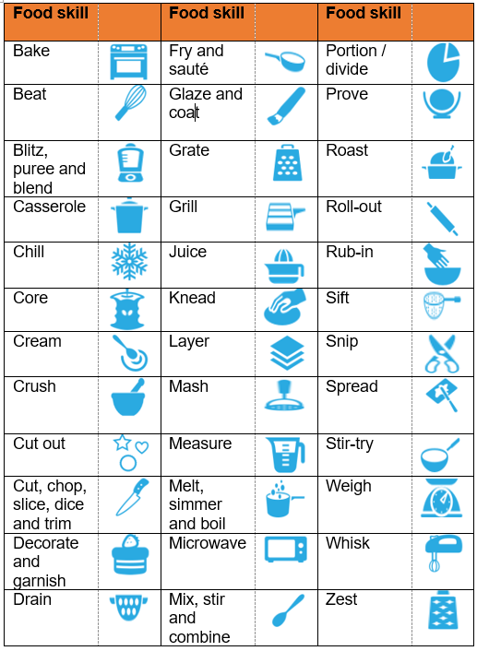

**Why is food cooked?**

Some foods can be eaten raw and form an important part of the diet. However, many foods need to be prepared and cooked before they are eaten to:

* make the food safe to eat by destroying pathogenic microorganisms and toxins;
* destroy microorganisms and enzymes that cause food to deteriorate and therefore increase the keeping quality of the food;
* make the food more digestible and easier to absorb.

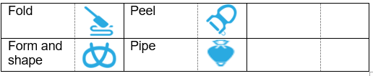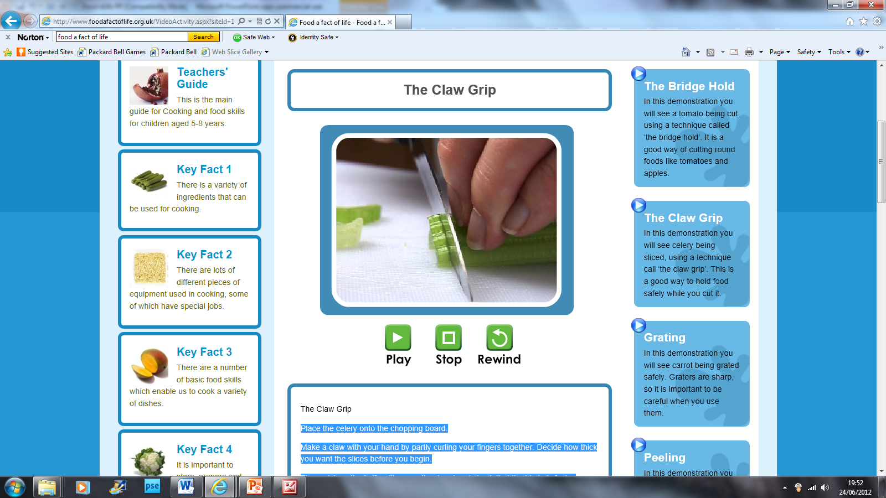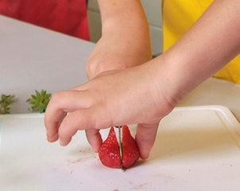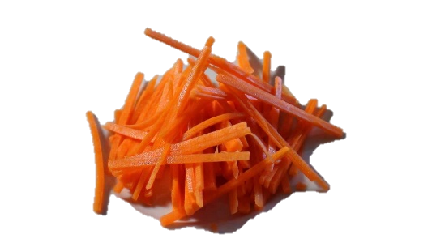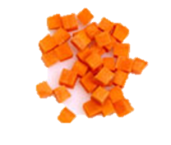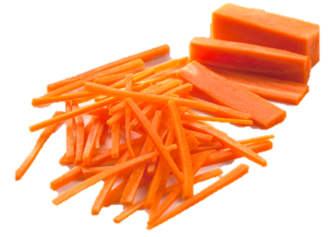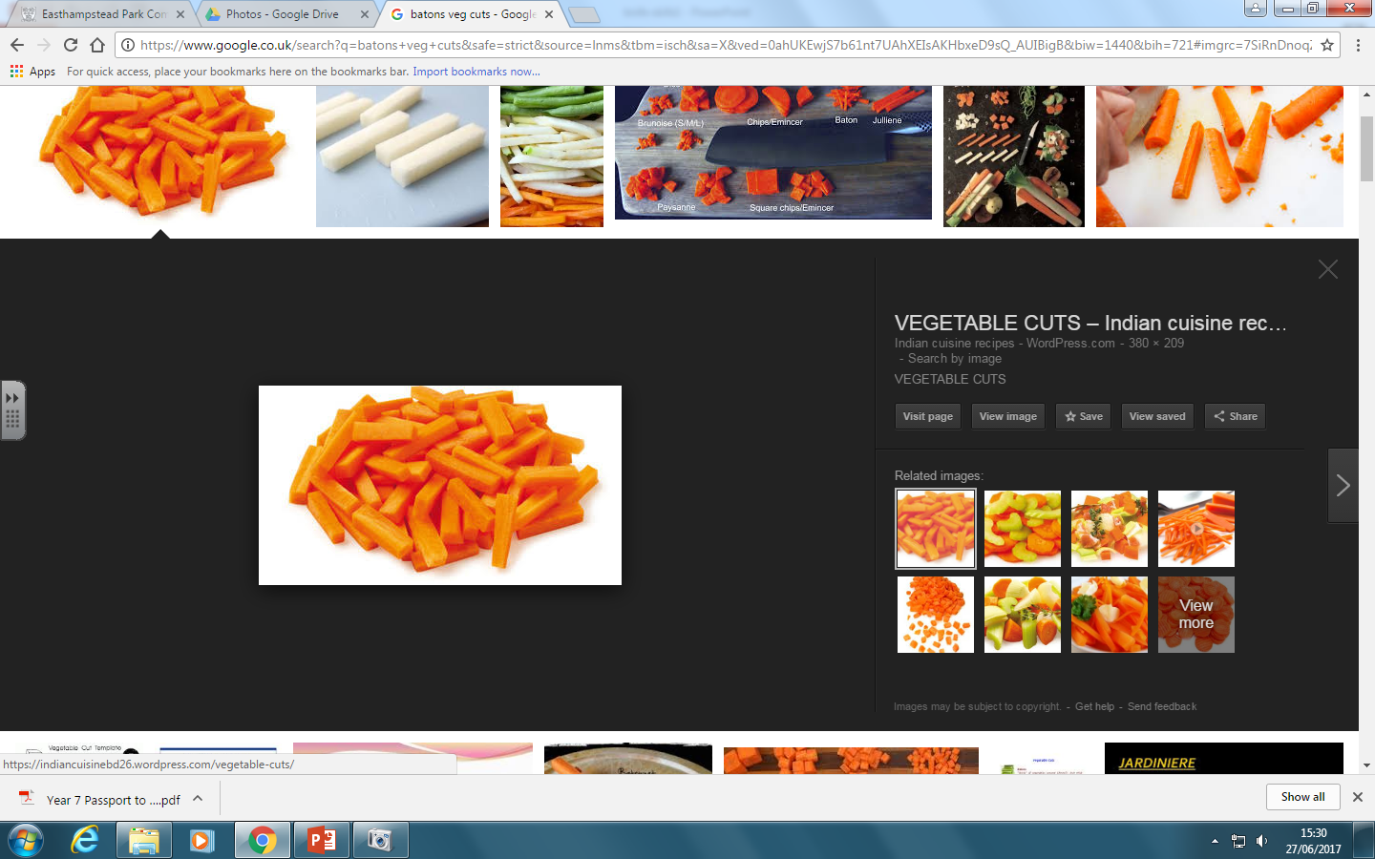

**Cooking for health**

Take into account healthy eating recommendations to ensure that dishes/meals are part of a varied, balanced diet.

* Planning - does the meal meet the nutritional needs and preferences of those it is being cooked for? Base your meals on starchy food.
* Choosing - choose low fat/sugar/salt versions, where possible.
* Preparing - limit the amount of fat added (try a spray oil) and replace salt with other flavourings, such as herbs and spices.
* Cooking - use cooking practices which reduce the amount of fat needed and minimise vitamin losses from fruit and vegetables.
* Serving - serve the meal in proportions which reflect current healthy eating advice.
* Do not forget to include a drink.

**Healthier cooking methods**

* Grill or BBQ foods rather than fry to allow fat to drain away.
* Drain or skim fat from liquids, e.g. sauces, stews and casseroles.
* Dry fry using non-stick pans, so no need for oil.
* Oven bake rather than fry.
* Steam or microwave vegetables.

**Cooking methods**

These are based on the cooking medium used:

* moist/water based methods of cooking, e.g. boiling, steaming, stewing, braising;
* dry methods of cooking, e.g. grilling, baking roasting, toasting, BBQ;
* fat-based methods of cooking – stir, shallow and deep fat frying.

**fine julienne – 5-6.5cm long x 1.5mm square**

**julienne/match stick – 5-6.5cm long x 3 mm square**

**batons – 5-6.5cm long x 1 cm square**

To find out more, go to: <https://bit.ly/322eSpr>

**Safety**

* Sharp knives: never walk around with a knife. Use the *bridge hold* and *claw grip* to cut safely.
* Grater: hold grater firmly on a chopping board. Grate food in one direction and leave a small amount at the end to prevent injury to knuckles.
* Hot liquid: drain hot liquid carefully over the sink using a colander.
* Saucepans: turn panhandles in from the edge, so they are not knocked.
* Hot equipment: always use oven gloves when placing food in and out of the oven.
* Spills: wipe up immediately.
* Electrical equipment: always follow instructions.

**Food skills**

There are a number of food skills which enable a variety of increasingly complex dishes to be prepared and made.

These can include:

* beating, combining, creaming, mixing, stirring and whisking;
* blitzing, pureeing and blending.
* kneading, folding, forming and shaping;
* knife skills;
* rubbing-in and rolling-out;
* use of the cooker: boiling/simmering/poaching, frying, grilling, roasting and baking.

**Vegetable cuts**

**Task**

Complete the *Food route Cooking journal*:

<https://bit.ly/3dYUibH>

**dice – 1cm square**