**­­­­­­Food spoilage, contamination and food poisoning – Year 9**

**Food spoilage**

As soon as food is harvested, slaughtered or processed it starts to change. This happens for two main reasons:

* autolysis – self destruction, caused by enzymes present in the food;
* microbial spoilage – caused by the growth of micro-organisms, i.e. bacteria, yeasts and moulds.

**Physical contamination**

Thiscan occur in a variety of ways at different stages of food processing and production. Some examples are:

* soil from the ground when harvesting;
* a loose bolt from a processing plant when packaging;
* a hair from a chef in the kitchen.

**Salmonella**

**Sources**

Raw meat, poultry and eggs. Flies, people, sewage and contaminated water.

**Signs and symptoms**

Onset 6-48 hours. Headache, general aching of limbs, abdominal pain and diarrhoea, vomiting and fever. This usually lasts 1 – 7 days, and rarely is fatal.

**Campylobacter**

**Sources**

Raw and undercooked poultry, unpasteurized milk, contaminated water.

**Signs and symptoms**

Onset 2 – 5 days (can be longer). Fever, headache and dizziness for a few hours, followed by abdominal pain.

**E Coli 0157**

**Sources**

Raw and undercooked meat and poultry. Unwashed vegetables. Contaminated water.

**Signs and symptoms**

Onset usually 3-4 days. Diarrhoea, which may contain blood, can lead to kidney failure or death.

**Food**

Bacteria need a source of food to grow and multiply, these food are usually high in moisture, fat and protein, and may be ready to eat. Food where bacteria rapidly multiply in is called a **high risk food**. For example:

* meat, meat products and poultry;
* milk and dairy products;
* eggs – uncooked and lightly cooked;
* shellfish and seafood;
* prepared salads and vegetables;
* Cooked rice and pasta.

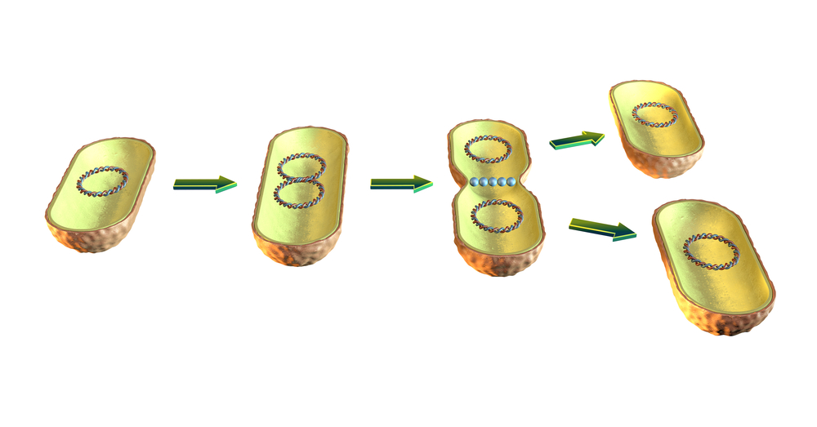

To find out more, go to: <https://bit.ly/3nE9fpE>

**Desirable food changes**

Desirable changes that can be caused by micro-organisms include:

* bacteria in yogurt and cheese production;
* mould in some cheeses, e.g. Stilton;
* yeast in bread production.

**Task**

Explain in detail the conditions bacteria need to survive and reproduce. Give examples of controls to reduce the likelihood of bacterial multiplication and risk of food poisoning.

**Allergens**

Allergenic ingredients can cause adverse reactions in some people. Care must be taken at each stage of food processing to prevent contamination.

**Staphylococcus aureus**

**Sources**

Humans: nose, mouth and skin. Untreated milk.

**Signs and symptoms**

Onset 1 – 6 hours. Severe vomiting, abdominal pain, weakness and lower than normal temperature.

This usually lasts 6 – 24 hours.

**Listeria**

**Sources**

Unpasteurised milk and dairy products, cook-chill foods, pâté, meat, poultry and salad vegetables.

**Signs and symptoms**

Onset 1-70 days. Ranges from mild, flu-like illness to meningitis, septicaemia, pneumonia.

During pregnancy may lead to miscarriage or birth of an infected baby.

**Key terms**

**Bacteria**: Small living organisms that can reproduce to form colonies. Some bacteria can be harmful (pathogenic) and others are necessary for food production, e.g. to make cheese and yogurt.

**Binary fission**: The process that bacteria uses to divide and multiply.

**Cross-contamination**: The transfer of bacteria from one source to another. Usually raw food to ready-to-eat food but can also be the transfer of bacteria from unclean hands, equipment, cloths or pests. Can also relate to allergens.

**Food spoilage**: The action of enzymes or microorganisms which make the food unacceptable to consume.

**Food poisoning**: Illness resulting from eating food which contains food poisoning micro-organisms or toxins produced by micro-organisms.

**Toxin:** A poison produced by some bacteria which can cause food poisoning.

**Food spoilage: Microbial spoilage**

Spoilage can be caused by the growth of:

* bacteria – single celled micro- organisms which are present naturally in the environment;
* yeasts – single celled fungi;
* Moulds – fungi which grow as filaments in food.

**Food spoilage: Autolysis – enzymes**

Enzymes are chemicals which can cause food to deteriorate in three main ways:

* ripening – this will continue until the food becomes inedible, e.g. banana ripening;
* browning – enzymes can react with air causing certain foods to discolour, e.g. apples;
* Oxidation – loss of nutrients, such as vitamin C from food, e.g. over boiling of green vegetables.

**Food contamination**

Food contamination can lead to food poisoning. There are three ways which food can be contaminated: **bacterial**,

**chemical** and **physical**.

**Chemical contamination**

Chemical contaminationcan occur in a variety of ways at different stages of food processing and production. For example, chemicals from the farm; cleaning products used in the processing plant and fly spray used in the kitchen.

**Micro-organisms**

Micro-organismsneed conditions to survive and reproduce these can include:

* temperature;
* moisture;
* food;
* time;
* oxygen and pH level.

**People at high risk of food poisoning**

Elderly people, babies and anyone who is ill or pregnant needs to be extra careful about the food they eat.

**Moisture**

Where there is no moisture bacteria cannot grow. However, bacteria and moulds can both produce spores which can survive until water is added to the food.

**Temperature**

Bacteria need warm conditions to grown and multiply.

* The ideal temperature for bacterial growth is 30ºC – 37ºC.
* Some bacteria can still grow at 10ºC and 60ºC.
* Most bacteria are destroyed at temperatures above 63 ºC.
* Bacterial growth danger zone is 5ºC - 63ºC.

At very cold temperatures, bacteria become dormant – they do not die, but they cannot grow or multiply.

**Bacterial contamination**

Most bacteria are harmless but a small number can cause illness. These are known as pathogenic bacteria. Food which is contaminated with pathogenic bacteria can look, taste and smell normal.

Bacteria can be transferred onto food through cross-contamination, via equipment, people or pests, or can be naturally present in the food.

Some bacteria can produce toxins which can cause food poisoning.

**Symptoms of food poisoning**

Food poisoning can be mild or severe. The most common symptoms are:

* feeling sick;
* being sick;
* diarrhoea;
* Abdominal pain.

**Time**

Given the right conditions, one bacterium can divide into two every 10-20 minutes through a process called binary fission.