**Hinduism Knowledge Organiser**

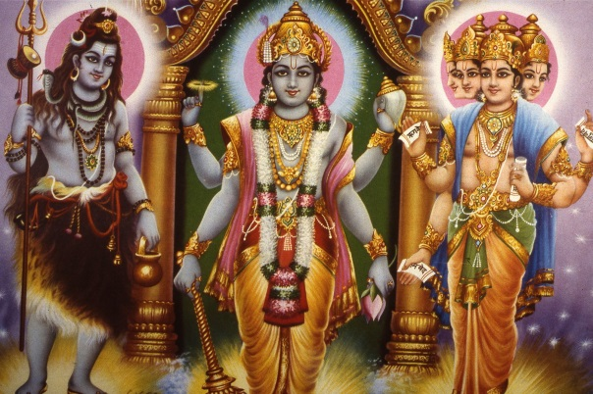**Key Words:**

|  |
| --- |
| **Dharma**- doing your duty and working as part of society |
| **Caste**- a social group you belong to. It cannot change |
| **Reincarnation**- the belief that when you die you come back as something else |
| **Moksha**- when you live a perfect life reincarnation stops and you are united with God |
| **Karma**- a cosmic force regarding your actions; good actions will get you good karma |
| **Mandir**- a Hindu temple |
| **Deity**- a god or goddess |
| **Puja**- a form of personal worship |
| **Yoga**- a form of personal worship involving body movements |
| **Festival**- a religious celebration |

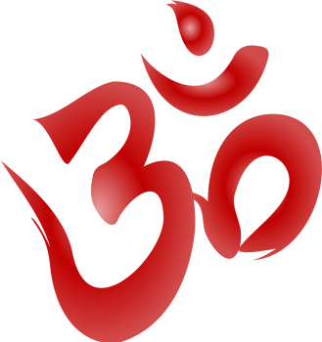

**Where does Hinduism come from?**

Hinduism is an ancient religion whose history stretches back thousands of years. The religion originated from India and has currently got around 900million followers worldwide. There is no set text or founder for Hinduism so therefore different Hindus practice the religion slightly differently from each other.

**Hindu beliefs about God**

Hindus believe in One supreme God called Brahman. Brahman is thought to be everywhere and in everything. God is so great that it is beyond our understanding. Hindus believe that we can never see or understand God fully. As they believe that God has no limits, God doesn’t have any definitive (exact) form (body/shape) God can be viewed in many different ways. The different deities are different ways that Brahman can be understood for different Hindus. The Trimurti contains the three most commonly worshipped Hindu deities.

**Trimurti – three most commonly worshipped Hindu deities**

**Brahma** – the creator **Vishnu** – the preserver **Shiva** – the destroyer

**The Mandir – Hindu place of worship**

The Hindu place of worship is called a Mandir. It is a place that contains all of the different things that Hindu might need in order to preform worship. Often Mandirs are dedicated to a specific Hindu deity. The Mandir will be a place where the whole community might gather during festival times in order to preform rituals and listen to the Brahmins (priests) preaching. Food which is given to the murtis (statues of deities) is often shard out amongst poor and homeless people after worship has taken place.

**Personal worship – yoga and puja**

There are four main forms of yoga that a Hindu might practice in order to take part in their faith. These are Jnana yoga – the path of the knowledge, those on this path will read and interpret sacred texts in order to gain greater knowledge about Brahman. Bhakti yoga – devotional service for Brahman, those on this path will perform many acts of worship such as going on a pilgrimage or preforming puja (ritual worship) in the home to show dedication. Raja yoga – the path of mediation, those on the path of meditation need to rid themselves of all other thoughts in order that they can focus all their time and energy on Brahman. Finally there is Karma yoga – the path of good works, those on this path will strive to lead a good life where they help others and do so in order to bring them closer to Brahman and be freed from the cycle of reincarnation.

**Hindu sacred texts**

Hinduism is a ‘family of religions’ as such it has no single set text as it. Despite there not being one book which all Hindus look to for advice and guidance; many will look to the epics of the gods in order to understand how they should behave in different situations. One of the more common stories that Hindus use is the Ramayana. It is the story of a god (Rama) with the help of a friend (Hanuman) rescuing his wife (Sita) from the demon (Ravanna)

Many different morals can be obtained from the Ramayana such as helping others who are in need, staying committed to your husband or wife and that good will conquer evil.

However some critics of Ramayana state that it was written very long ago and is no longer applicable to today’s world, there isn’t any evidence of a battle taking place and that it seems to encourage people to go to war.

**Hindu festivals – Diwali**

Diwali is the known as the festival of lights. It is a celebration of the return of Rama and Sita. The festival is celebrated over five days.

Day1 – creation and washing away of rangoli patterns to remind Hindus that pride is not a good thing. Food is prepared and oil lamps are lit in order to remind Hindus of Rama and Sita’s return. Day2 – family will celebrate together and people will forgive those who have wronged them in the past 12months. Day3 – this is the main day of festival. Hindus will celebrate by going to the Mandir with family and decorate their homes to welcome Lakshmi (goddess of wealth) in the hope that she will bring them good luck in the new year. Day4 – this is the start of the new year. Hindus will go to the Mandir and ask the gods and goddesses for a good new year. Children will receive presents and they will remember good overcoming evil in the Ramayana. Day5 – brothers and sisters should be together on this day. They will exchange gifts, the sister will give her brother a bracelet, when he accepts, and it is a symbol of his duty to always protect her.

**Hindu festivals – Holi**

Holi is the Hindu festival of colour. It is celebrated in honour of Lord Vishnu. The festivals is based off the story of Holika and Prahlad, in the story Prahlad who was a follower of the god Vishnu was saved from burning in a fire because of how strong his faith was, Holika however was consumed by the flames because she tried to harm Vishnu’s follower. During the festival Hindus will throw coloured powder at each other and everyone will get involved. At night time Hindus will attend large parties with bonfires and fireworks, During this festival all caste boundaries are removed and everyone will mix, it doesn’t matter if they are a Brahmin (priest), Kshatriyas (warriors), Vaisyas (merchants) or Sudras (servants); everyone will look the same and all enjoy the festivities.