The Amazon Rainforest 1 - Weather and Climate
Map of the Amazon Rainforest  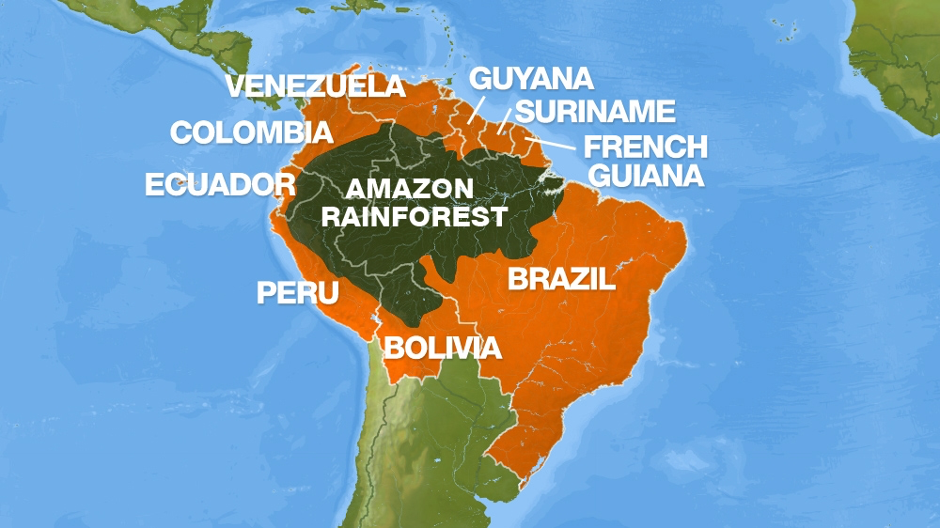 | What is a tropical rainforest (TRF)?  Tropical rainforests are found between the Tropics of Cancer and Capricorn, 23.5° north and south of the equator.  The tropical rainforest contains far more species of plants and animals than any other biome. They cover approximately six per cent of the Earth's surface, and because they get 2,000 mm of rain per year and temperatures range from around 27 to 32°C, conditions are wet and hot all year round so it is a good environment for growth.  The Amazon Rainforest is located in the continent of South America. It covers multiple countries - but is largely located in Brazil. Brazil is in the north east of South America and touches the Atlantic Ocean.
Why are the world’s rainforests near the Equator?  - Rainforests are created by hot, humid weather. These conditions are created by the Hadley Cell.  - Due to the curvature of the Earth, the Equator receives large amounts of solar radiation. This makes it hot.  - The hot air at the Equator rises, and drags up moisture making tall storm clouds.  - The band of storm clouds around the Equator is known as the ‘Inter-Tropical Convergence Zone’.  - These clouds create lots of convectional rainfall - leading to hot wet conditions. | 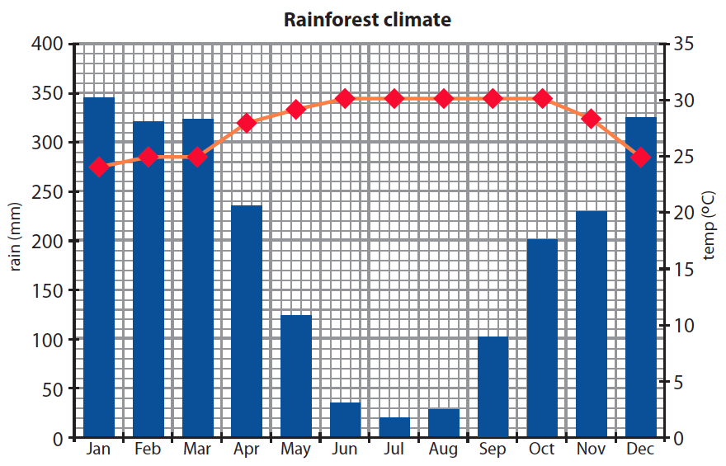  The Amazon is very hot all year round - as shown by the red line.  It also very wet - as shown by the blue bars.  The Amazon has a slightly drier season between June and August. This is caused by changes to the position of the ‘Inter-Tropical Convergence Zone (ITCZ)’ - a band of warm, wet air.
Humid = air with lots of water vapour in it.
Solar Radiation = energy from the sun.

The Amazon Rainforest - Layers of the Rainforest
Emergent Layer  - The tallest layer - over 40 metres.  - Contains only a few tall trees which grow taller than the trees of the canopy.  - The plants are made for living in dry conditions because it’s very sunny.  - They have small, waxy leaves to prevent them drying out.  - Eagles, butterflies, small monkeys and bats all live here.  Canopy  - The second highest layer - 30-45 metres.  - The crowns of the trees knit together to form a dense canopy.  - The canopy blocks out the sun from lower layers and intercepts (catches) rainfall.  - It contains the most plant species.  - Birds, monkeys, frogs, sloths, lizards, snakes and many insects live here. This layer contains the most animal species. Some creatures never go to the forest floor.  Understory  - Low light conditions (2-15%).  - Quite open - there is only dense vegetation along rivers and in openings where light gets in.  - Plants adapted to low light grow here.  - Birds, butterflies, frogs, snakes and lots of insects live here.  Forest Floor  - Very little light reaches the forest floor (2%) - so plants grow slowly.  - The ground is covered in fallen leaves, rotting branches and twigs and a network of shallow roots.  - When a tree falls, light is able to get in. This encourages young plants to grow fast. They compete for the extra light and soon fill the gap.  - Jaguars, leopards, tigers, elephants and gorillas are found in different rainforests around the world. Lots of insects live here | 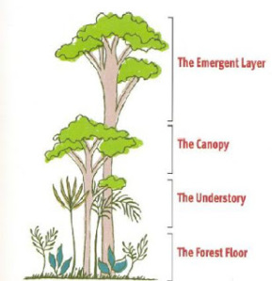

The Amazon Rainforest 3 - Adapting to the TRF
The warm, wet conditions of the Amazon Rainforest is perfect for plant growth. This has led to challenges as plants and animals compete for resources. To survive, plants and animals have adapted in special ways to the conditions of the TRF.
Plant adaptations  The following adaptations allow plants to survive in the conditions of the rainforest.  - Lianas - these are woody vines that have roots in the ground but climb up the trees to reach the sunlight. Their leaves and flowers grow in the canopy.  - Tree trunks - these are tall and thin to allow trees to reach the sunlight. The bark on these trees is smooth to allow water to flow down to the roots easily.  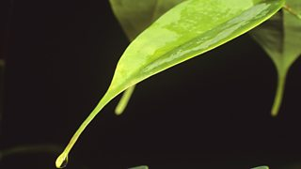  Drip tips - plants have leaves with pointy tips. This allows water to run off the leaves quickly without damaging or breaking them.  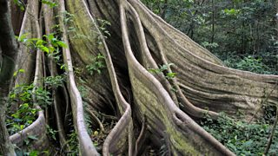  Buttress roots - large roots have ridges which create a large surface area that help to support large trees.  Epiphytes - these are plants which live on the branches of trees high up in the canopy. They get their nutrients from the air and water, not from the soil. | Animal adaptations  Many animals have adapted to the unique conditions of the tropical rainforests.  - The sloth uses camouflage and moves very slowly to make it difficult for predators to spot.  - The spider monkey has long, strong limbs to help it to climb through the rainforest trees.  - The flying frog has fully webbed hands and feet, and a flap of loose skin that stretches between its limbs, which allows it to glide from plant to plant.  - The toucan has a long, large bill to allow it to reach and cut fruit from branches that are too weak to support its weight.  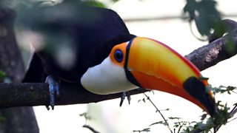  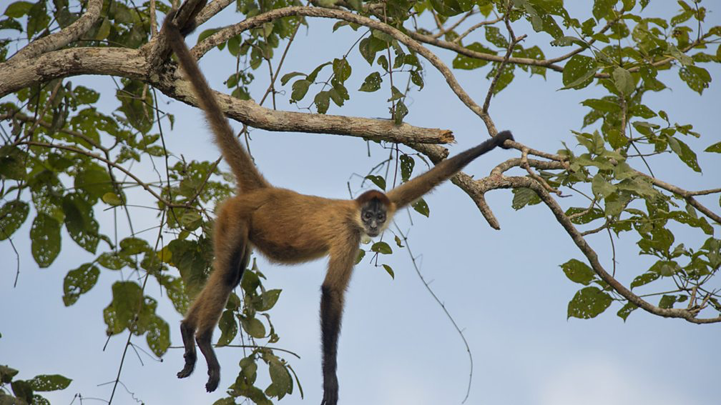

The Amazon Rainforest 4 - Using the Rainforest

What use is the Amazon Rainforest?  In the Amazon, there is pressure to use rainforest resources to help development but this can lead to resources being exploited in an unsustainable way. Some developers are willing to do anything to make money but there would be long-term negative impacts for the whole planet.  The rainforests are so important because they are home to:  - oxygen - the rainforest vegetation takes in carbon dioxide and gives out oxygen  - medicines - a quarter of all natural medicines were discovered here  - undiscovered species  - food, eg vanilla, chocolate, nuts, ginger and pepper  - resources, such as rubber and bamboo  - wood  - minerals  - river networks | Keywords  Sustainable = something that causes little or no damage to the environment and therefore is able to continue for a long time.  Mining = digging precious minerals out of the ground. E.g. mining for diamonds.  Logging = chopping down trees for use as timber. This might be using wood to build houses or other buildings.  Agriculture = farming.
There are many benefits to using the Amazon’s resources…

- Improved transportation - new roads and airports. Better transportation means easier access to raw materials like minerals and timber. Rainforest resources can be transported away and sold.
- Infrastructure, hospitals and education can be improved from the money gained from selling natural resources.
- Profits from selling resources can be used to improve a country's infrastructure. For example, profits from the sale of rainforest resources can be used to build schools and hospitals.
- Raw materials, eg tropical hardwoods such as ebony and mahogany, can be sold for a good price abroad.
- Mineral deposits in the Amazon include bauxite (the main constituent of aluminium), iron ore, manganese, gold, silver and diamonds. Minerals can be sold for high profits.
- Large-scale farming brings money into the country and provides food and jobs for the country's growing population.
- Small-scale farming provides food for rainforest communities and the landless poor of Brazil.

The Amazon Rainforest- Deforestation
However, there are also disadvantages to using the Amazon’s resources…  - New roads divide up parts of the rainforest. For example, a road can stop monkeys such as the golden lion tamarin from travelling to gather food and, in turn, distribute seeds to re-sow plants in the forest.  - Land clearance for farming, transportation and mining can lead to deforestation. Hardwood trees take many years to grow so can be difficult to replace.  - Fertile soils that make farming possible are quickly washed away when the forest is cleared. If soil ends up in rivers, this can lead to flooding.  - Loss of animal habitat occurs when trees are cut down. Hence, deforestation can result in endangering animals and plant life, or even causing them to become extinct.  - Profits from large-scale farming and selling resources often go back to developed countries or large companies and don't benefit the rainforest communities. | Keywords  Deforestation = chopping down trees.  Afforestation = planting trees.  Carbon Dioxide = a gas taken in by trees. It is a greenhouse gas and can cause climate change.  Oxygen = a gas emitted by trees.  Settlement = an area built for humans to live in.
Deforestation is usually caused by a number of reasons…
- Commercial logging companies cut down trees for timber, which is mostly sold to developed countries.
- Farming: land is cleared (eg by slash and burn) and planted with cash crops, usually just one - such as palm oil. Alternatively, it will be used for grazing by cattle ranchers. Most cash crops and cattle are eventually sold to developed countries.
- Mining: land is completely deforested. Soil is often removed with high-pressure hoses and chemicals are used. The run-off goes into local rivers and pollutes them. Huge scars from open-cast pits are left - the soil can't recover.
- Road building: loggers and miners build roads to get their materials out. People use the roads to enter the forest and build new settlements and set up industries. The Trans-Amazonian Highway in South America is 5,300 km long and has opened up some remote parts of Brazil to development.
- Settlement: land is being cleared for new homes and settlements. There is more need for these in countries with increasing populations, especially around large overcrowded cities.
- Dam building: Hydro-electric dams provide clean energy but also result in deforestation.
- Fuelwood: many people rely on wood for their main source of fuel, particularly in developing countries.

The Amazon Rainforest 6 - Managing the Rainforest

Brazil needs to exploit the Amazon's resources to develop, so leaving it untouched is not an option.

Uncontrolled and unchecked exploitation can cause irreversible damage such as loss of biodiversity, soil erosion, flooding and climate change. So, sustainable use of the forest is essential.

Sustainable development will meet the needs of Brazil's population without compromising the needs of future generations.

Possible strategies include:
- Agro-forestry - growing trees and crops at the same time. This lets farmers take advantage of shelter from the canopy of trees. It prevents soil erosion and the crops benefit from the nutrients from the dead organic matter.
- Selective logging - trees are only felled when they reach a particular height. This allows young trees a guaranteed life span and the forest will regain full maturity after around 30-50 years.
- Education - ensuring those involved in exploitation and management of the forest understand the consequences behind their actions.
- Afforestation - the opposite of deforestation. If trees are cut down, they are replaced to maintain the canopy.
- Forest reserves - areas protected from exploitation.
- Monitoring - use of satellite technology and photography to check that any activities taking place are legal and follow guidelines for sustainability.

