The Planet’s Natural Resources 1 -Types of Resources
LI: To define natural resources and know where they are distributed.
What are natural resources?
Natural resources are materials or substances that are produced by the environment. Humans use natural resources to survive. They can be used to heat our homes, transport us around the world, feed us and clothe us. They include: fossil fuels (oil, coal and gas), crops (like wheat) and minerals (such as iron ore).

Natural resources can be renewable or non-renewable. A renewable resource is something that will never run-out - for example, wind power or solar power.
Keywords  Demand - the need for something.  Consumption - using a resource.  Distribution - how something is spread out over an area.  Fossil Fuels - oil, coal and gas.  Mineral - substances found naturally in the Earth. E.g. iron ore.  Renewable - a resource that will not run out.  Non-Renewable - a resource that will run out. | 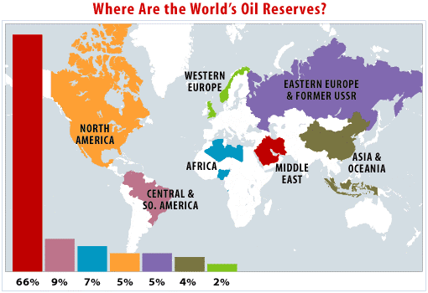
Geography Skills: Describing a Map  When you are asked to describe a map, remember TEA:  - TREND = what is the overall pattern? E.g. where is the most oil?  - EXAMPLE = back-up your answer with data from the map - e.g. a country.  - ANOMALY = is there an odd result? | How are the world’s resources distributed?  - The world’s resources are not distributed fairly. This means some countries have more than others.  - The above map shows the distribution of the world’s oil - the majority is in the Middle East. This can cause problems and influence global relations.  - Countries need to acquire basic resources such as oil, water and food in order to survive.

The Planet’s Natural Resources 2 - Oil

LI: To understand how oil is formed and why it is important.
What are fossil fuels and how were the created?  Fossil fuels are non-renewable resources - they are coal, oil and natural gas. They can be burned in power stations to generate electricity.  Oil and gas were formed from the remains of animals and plants that lived millions of years ago in the sea. These remains were covered by layers of sand and silt. Heat and pressure from the Earth's core turned them into oil and gas. The oil and gas were trapped between layers of impermeable rocks.  Coal was formed from dead plants about 300 million years ago. Back then, much of the Earth was covered by swamps. As the vegetation died, it decayed, slowly forming layers of peat. Over time this was covered with more sediment and compressed and heated to form coal. | 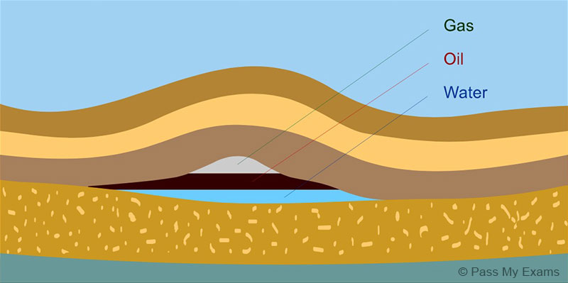

Advantages of Fossil Fuels | Disadvantages of Fossil Fuels
- They generate large amounts of energy quite cheaply.  - Locating where fossil fuels are is quite easy.  - Oil and gas can be transported through pipelines.  - The means for extracting fossil fuels is already in existence. | - Carbon dioxide contributes to the greenhouse effect and global warming.  - Mining can create ugly scars on the landscape.  - Oil spills can cause environmental damage.  - Supplies are running out and new sources are harder to get to. Oil and gas are both predicted to run out within 100 years.  - Oil is mainly produced outside the UK so prices are set by other countries.

The Planet’s Natural Resources 3 - Trading Natural Resources

LI: To understand the factors affecting the trade of natural resources.
The trading of natural resources is vital for the global economy. Countries rely on each other supplying their resources - and this causes a variety of problems.
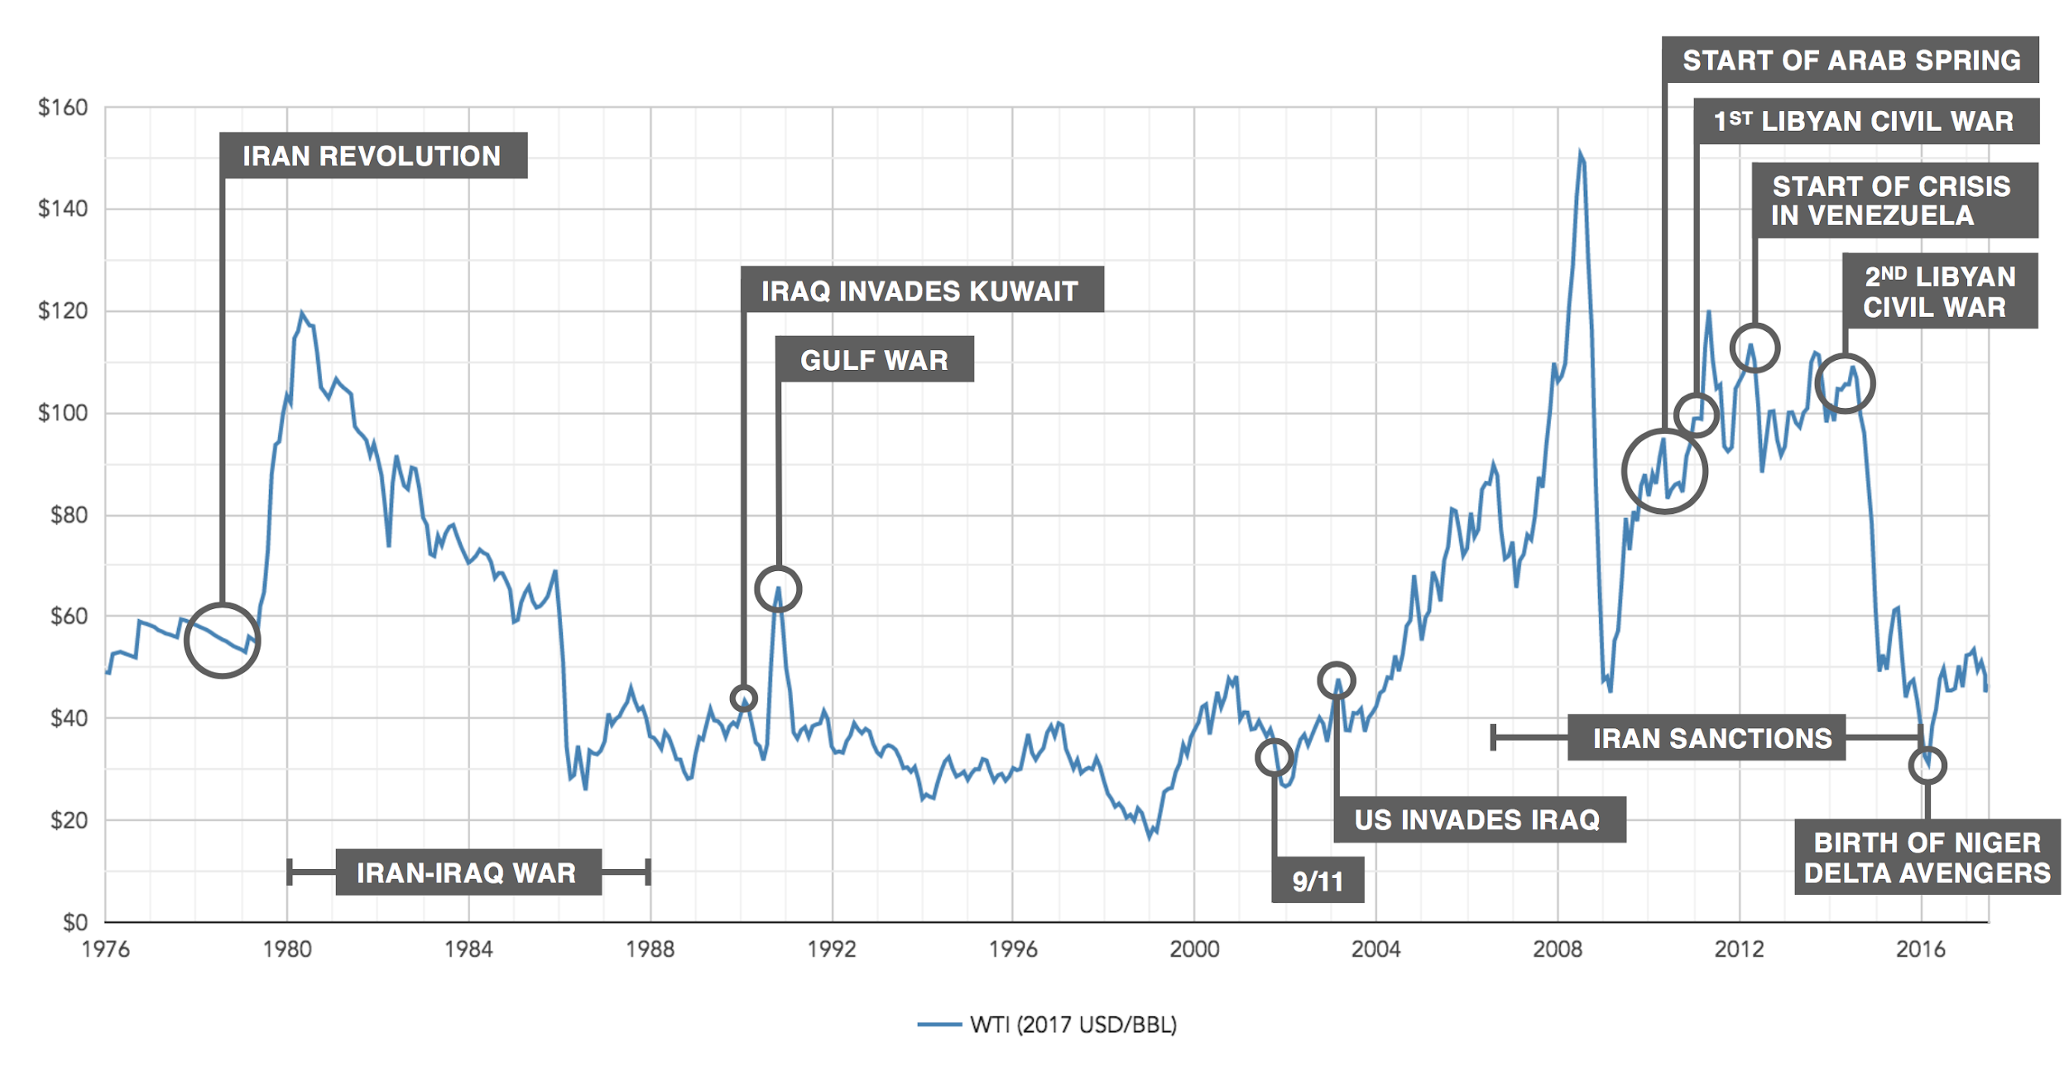This graph show the changing prices of oil from 1976 to 2014. As you can see, the price changes massively. This is often due to war and conflict in oil producing countries. | How does the price of oil affect the world?  - The price of crude oil is controlled by oil companies, which means they have a great deal of influence on the global economy, and poorer countries can easily lose control of their own economy.  - Countries that produce oil for other countries hold a great deal of political power as they can essentially ‘cut off’ other countries from the crude oil supply over any political disagreements.  - War or a political crisis in an oil-producing country can restrict crude oil supplies, which can have a major impact on the global economy.  - When the price of oil goes up, countries can suffer. This is because the price of oil affects lots of aspects of everyday life - from the price of petrol in cars to people;s electricity bills.
Geography Skills - Describing a Graph. Use TEA (see pg1). With the trend, try zoom out - what is the graph telling me overall? E.g. in the graph above - are prices going up or down on the whole. In the anomaly, tell me are there exceptions to this trend.

The Planet’s Natural Resources 4 - China in Africa

LI: To understand how and why China is investing in Africa.
Why is China interested in Africa?  - China has become a rapidly growing economy. It specialises in making things - from iPhones to washing machines. Most of your household items are made in China.  - To do this, China needs the natural resources to make these goods - iron to make steel or coal to generate the electricity needed to power its factories.  - Africa has a lot of natural resources (see map on the right).  - Africa has 50% of the world’s gold, 90% of the world’s cobalt, 90% of the world’s platinum.  - China buys ⅓ of Africa’s oil - mainly from Angola.  - China buys Africa’s resources.  - In return, China has sponsored development projects: e.g. $8m pipeline in Sudan, large high-speed railway in the Democratic Republic of Congo.  - They have also loaned money to 31 African countries.  - China has also cancelled $10 billion worth of debt from a number of other African countries  - People argue China only does this to help them get natural resources. | 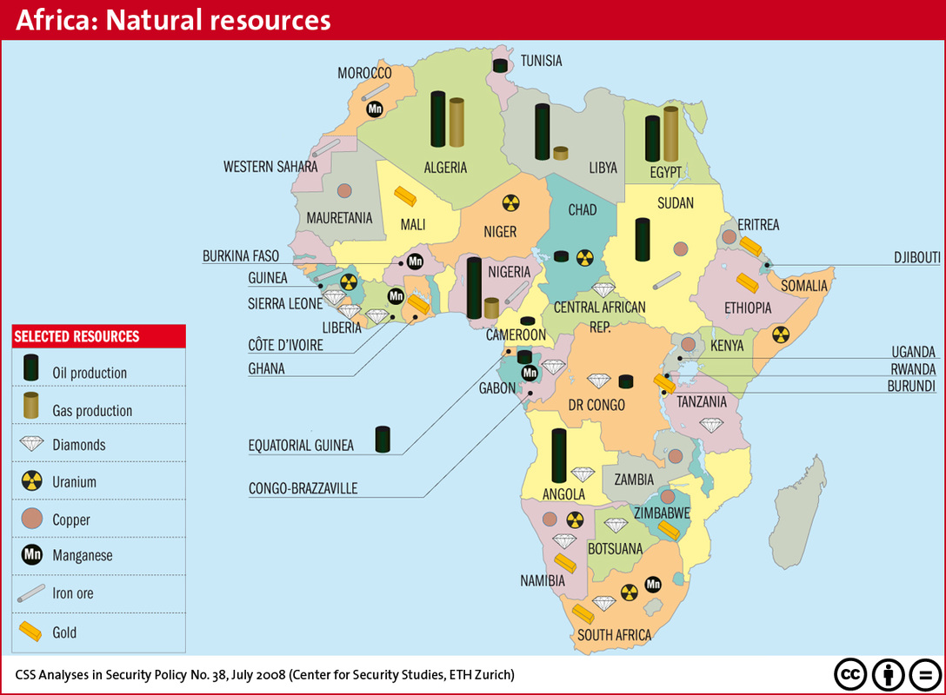  Map of Africa’s Natural Resources
Resource Curse Theory? Africa has the majority of the world’s minerals (e.g. platinum, cobalt). To some people- this is a chance to get rich. They can sell these to industrial countries like China. To others, this is a curse - there have been many wars over resources such as oil. Countries such as Nigeria has been plagued with war since independence. Relying on mining also brings up problems for the future - once the resources run out - how will people earn money?

The Planet’s Natural Resources 5 - Oil in the Niger Delta (Case Study)

LI: to understand how the oil industry is affecting Nigeria.
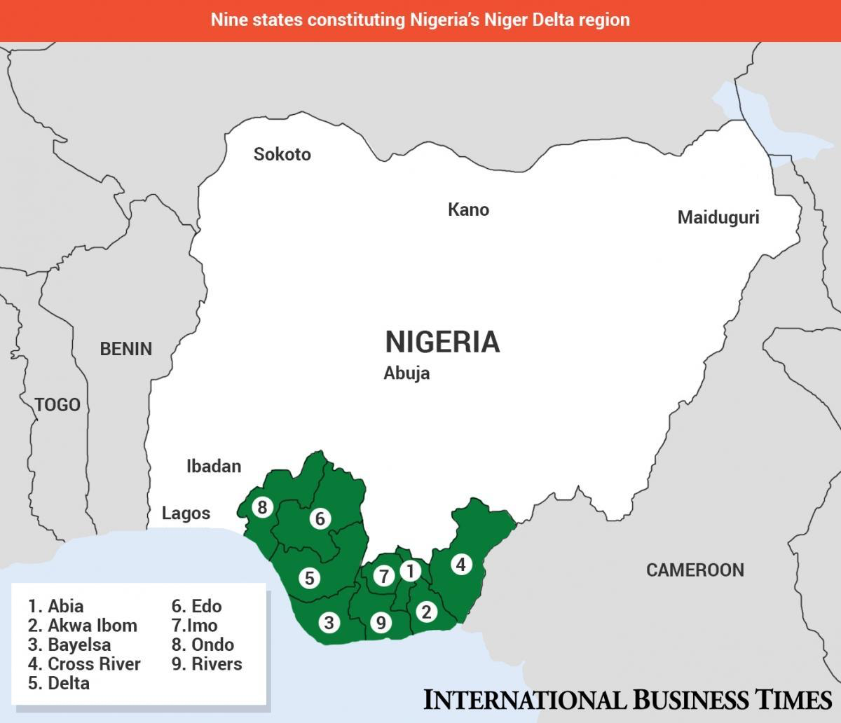  Map showing the Niger Delta Region, Nigeria | 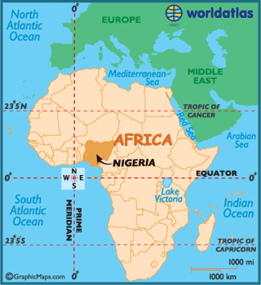 | Where is the Niger Delta?  The Niger Delta is a region of Nigeria in West Africa.  A delta is a marshy area where a river meets the sea. The Niger Delta is especially rich in wildlife - with rich mangrove swamps, different species of monkeys and hippos.  The Niger Delta is also very rich in oil. This has created opportunities for local people to work in the oil industry. But it has also created war and conflict.

Geography Skills: Writing 8 Mark Answers and Using Case Studies…
When you are writing longer answers (8 markers), remember to include case studies (real life examples like this one!).
Describe the location of your case study (the Niger Delta) and try to remember specific facts from the lesson. You can use these to back up your answer.
E.g. Oil in the Niger Delta has led to a number of environmental problems. For example, in 2009 14,000 tonnes of crude oil was split. This impresses the examiner everytime!

Benefits of Oil in the Niger Delta | Problems with Oil in the Niger Delta
- Oil is the biggest industry in Nigeria. It accounts for 98% of the region’s earnings.  - Tax revenue (money taken from the industry’s profits) has helped to build factories and schools all over Nigeria.  - Companies such as Shell and British Petroleum (based in Holland and the UK respectively) have invested (put a lot of money) into Nigeria because of oil. This is known as Foreign Direct Investment (FDI).  - In 2009, Chinese company spent $8 billion on an oil refinery in Lagos, Nigeria. This created hundreds of good jobs for the local area.  - Nigeria hopes to develop into an emerging economy - and thinks that selling oil is the best way to do this. | - It is estimated that 1% of workers in Nigeria’s oil industry receive 80% of the money in it. This is called inequality.  - Nigeria might be an emerging country but large numbers of people are living in extreme poverty.  - The UN estimates 45% of the country lives in absolute poverty – particularly villagers, farmers and workers in the Niger Delta region.  - Because oil is so valuable, the government have concentrated on it.  - This has meant farming has been ignored.  - Agriculture (farming) makes up 25% of Nigeria’s wealth. It also employs 2/3 of the population.  - Since 1970, it is estimated that there have been 7000 oil spills in the Niger Delta region.  - In 2009 , 14,000 tonnes of crude oil was split.  - This killed thousands of birds, destroyed an entire Mangrove swamp and all that lived in it.  - Due to the environmental problems, a number of terrorist groups have begun to sabotage (attack) oil pipelines.  - One group, named the ‘Movement for Emancipation of the Niger Delta’ (MEND), have killed a number of oil workers in an attempt to get rid of oil companies from the region.  - Other militant groups (such as the Niger Delta Avengers) battle over controlling oil wells. In the absence of a strong military, criminal gangs steal oil and sell it to each other for huge amounts of money.

