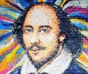KNOWLEDGE ORGANISER:  
***Julius Caesar (c.1599)***

**Context**

* The play is based on the true story of the assassination of Julius Caesar, a famous Roman leader.
* Ancient Rome was governed by a group of senators (affluent members of society).
* Julius Caesar was an incredibly successful war general. The senators appointed Caesar as the leader of Rome due to the rising fear of war.
* Caesar refused to follow many rules and requests of the senate, and they feared he wanted to make himself king. As a result, many senators, led by Cassius and Brutus, planned to assassinate (murder) Caesar.
* Caesar was killed in 44 BC. He was stabbed at least 23 times.
* The assassination caused a civil war in the Roman Empire.

**Shakespeare’s Intentions**

Although Shakespeare was writing centuries ago, his works are still relevant today. Many of his plays are social commentaries, exploring how and why people act the way they do.

**Within ‘Julius Caesar’, Shakespeare explores:**

* **the consuming power of obsession.**
* **how far life is controlled by fate.**

**Core Knowledge**

|  |
| --- |
| What are the differences between **democracy** & **tyranny**? |
| A **democracy** is ruled by citizens of a country, as a form of government. The government would vote, or decide together, on decisions made.  A **tyranny** is a government with a single ruler (a tyrant) who has absolute power over all decisions. This can often lead to the oppression and exploitation of people. |

|  |
| --- |
| What are the **conventions of a Shakespearean tragedy**? |
| Although the stories were all very different, Shakespeare’s tragedies would include:   * A **tragic waste of life** – it is not just the evil and villainous characters that die in a tragedy. * **Conflict**, usually between **control and freedom**. * **Fate** vs **free will**. * **Omens** (often from dreams, visions or the supernatural). * A **tragic hero** (more information below). |

|  |
| --- |
| What is a **tragic hero**? |
| * Wicked Movie: Who Is Elphaba? Actress & Character Details ExplainedThe tragic hero is the main character in a tragedy, usually a high-born character who is **virtuous**, **honourable** and respected. * The tragic hero has **hamartia**: a flaw in their character that leads to their **downfall** and/or death. (The moment that a tragic hero’s hamartia starts to cause their downfall and their fortunes go from good to bad is called *peripeteia.*) * During their downfall, the tragic hero faces challenges or obstacles, but is unable to overcome them. This is often because their **hubris** blinds them to their own mistakes. * The tragic hero usually realises the truth about their situation towards the end of the play, but it is too late as they are already fated to die. (This moment of realisation is called *anagnorisis.*) * This death or downfall can create **pathos**. We pity them. |

|  |
| --- |
| What is the structure of a tragedy? |
| The structure of a tragedy play revolves around **the tragic hero** and their downfall.   * At first, the audience are introduced to the tragic hero. We are able to see what they are like and work out what their **hamartia** might be. At this point, the tragic hero is unaware of their hamartia. * During the story of the play, we see bad things happen to the tragic hero. These things happen as a result of their hamartia. This reversal of fortune is called their **peripeteia**. * Towards the end of the play, the tragic hero has a moment of **anagnorisis**. This is when they finally realise what their hamartia is. This happens too late, and is usually what leads to the tragic outcome. * The death or downfall of the tragic hero creates **pathos**. We feel pity for the character as we see that their downfall was avoidable, but the tragic hero does not realise this until it is too late. |

|  |
| --- |
| What is fate and why might Shakespeare include it in his plays? |
| * Many people believe that what happens to them in their lives is the work of **fate** and destiny. They believe that the decisions that they make and any events in their life are **predetermined** – that they have been decided in advance. * Many tragic heroes in tragedy plays, including in *Julius Caesar*, attempt to control their lives in order to prove that they have free will, but in the end they are unable to change their lives for the better and they cannot escape what happens to them. * In Shakespeare’s plays, he explores how far fate is to blame for the tragedy, or how far it is the tragic hero’s hamartia that is to blame. He likes to get his audience thinking about questions like this and the role that something like fate might play in our own lives, which is one of the many reasons his works are still enjoyed and discussed today. |

**Key Characters**

|  |
| --- |
| **Brutus** |
| Brutus is a senator in Rome. He is the **tragic hero**: his **hamartia** is his **honour**. His **virtuous** nature means he will do anything to protect Rome, but this allows him to be **manipulated** by Cassius.  He loves Caesar but becomes worried that he will become king as he would have too much power. Brutus shares his concerns with Cassius and is convinced to join the plot to assassinate Caesar. Brutus is the one that stabs Caesar the final time.  Brutus is unable to save Rome after the assassination – it causes civil war. Once he realises his mistake, he sees the ghost of Caesar who tells him it is time for him to die. He kills himself by running into his own sword. |
| **Cassius** |
| Cassius is a senator in Rome and also a general. He is **ambitious** and jealous of Caesar’s rise to power. He does not think that Caesar should become king, and constantly describes him as weak.  Cassius is **manipulative** and forges letters to convince others, including Brutus, to murder Caesar.  Cassius’ **obsession** with power causes the assassination, and when he realises he will not win, he asks one of his servants to kill him. |

|  |
| --- |
| **Julius Caesar** |
| Caesar is a general and is chosen to be the leader of Rome. At the beginning of the play, he returns from winning a battle and the Roman people want him to be king, but he refuses the crown.  He does not believe in fate and superstition. Despite many warnings and **omens** about his death, including from his wife, he refuses to believe the senators would betray him.  His **hubris** leads him to think that no-one can hurt him. |
| **Calpurnia** |
| Calpurnia is Caesar’s wife. She is **superstitious** and believes in fate, so she worries about omens of Caesar’s death.  After these omens and terrible nightmares, she tries to convince Caesar not to go to the senate on the day of his assassination. |
| **Marc Anthony** |
| Marc Anthony is a general in the Roman army and Caesar’s closest friend.  When Caesar is murdered, his persuasive speech convinces the Roman people to turn against the senators, leading to civil war. |

**Rhetoric**

**Marc Anthony uses rhetoric in his speech to the Roman plebeians (public). At first, the plebeians support Brutus and the reasons why the senators assassinated Caesar. Marc Anthony uses rhetoric to persuade the plebeians to turn against the senators.**

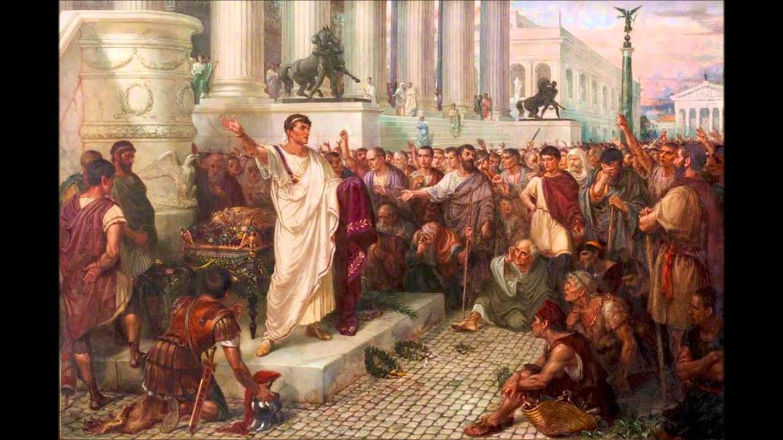

|  |  |
| --- | --- |
| **Rhetoric = writing or speech to influence people.**  Rhetoric is about being convincing, and **persuading** an audience to agree with what you’re writing or saying. | |
| **Ethos** | **ethos** = being **trusted** (truthful, experienced, knowledgeable)  The speaker must show they can be trusted, and have experience/ knowledge about the topic. The audience must find them believable. |
| **Logos** | **logos** = being **logical** (having clear reasons and evidence)  The speaker uses clear reasons and evidence (e.g. facts) to support their argument. Their argument makes sense and has a structure. They might show what will/won’t happen in the future if things do not change. |
| **Pathos** | **pathos** = appealing to the audience’s **emotions**  The speaker uses description/language that makes the audience feel an emotional reaction that persuades them to agree. |
| **Ways to create ethos, logos and pathos can be found on your Transactional Writing Strategy document.** | |

**Key Vocabulary**

|  |  |
| --- | --- |
| **Word** | **Meaning** |
| **ambition** | A strong desire to achieve something, usually power or success. |
| **consuming** | When someone has so much of a feeling it affects everything they do. |
| **democracy** | When people in society vote for a leader. |
| **dramatic irony** | When the audience knows something that the characters don't. |
| **exploitation** | The act of treating someone unfairly to benefit from their work. |
| **foreshadowing** | When a writer hints about something that happens later on in the story. |
| **honour** | Reputation and respect because you do the right thing. |
| **hubris** | Too much pride or self confidence |
| **internal conflict** | A struggle within someone’s mind over a problem. |
| **juxtaposition** | When a writer places different things next to each other for a reason. |
| **manipulate** | To control or influence something or someone unfairly. |
| **obsession** | The state of always having something on your mind. |
| **omen** | A symbol or sign used as a warning that something bad is going to happen. |
| **oppression** | The treatment of a group of people in an unfair way, often by limiting their freedom |
| **pathetic fallacy** | When a writer uses the weather to reflect human emotions. |
| **persuasion** | The act of convincing someone to do something or believe something. |
| **rhetoric** | Writing or speech to influence people. |
| **setting** | Where and when a story takes place. |
| **soliloquy** | A speech in a play where the character speaks to themselves or to the audience, usually to reveal their inner thoughts. |
| **superstition** | A non-scientific belief in how supernatural things can affect your luck or fate. |
| **tyranny** | A government with a single ruler (a tyrant) who has absolute power over all decisions. |
| **virtuous** | When someone is always moral (good). |