**Where food comes from – food processing**

**Where food comes from**

No matter where it is bought from, food is grown, reared or caught, then processed in some way, to make it edible and safe to eat.

**Pasteurisation, sterilisation and irradiation**.

The shelf life of food can be extended if sufficient heat is applied to kill microorganisms and inactivate the enzymes that are present.

**Pasteurisation** – extends shelf life by killing most food spoilage organisms and pathogenic organisms. Products are treated with mild heat, usually to less than 100°C for 30-35 minutes.

**Sterilisation** – is a more severe process that destroys all microorganisms.

**Irradiation** – produces an effect in food similar to pasteurisation.

**Food Manufacturing**  
Modern processing has developed over the centuries, with canning and pasteurisation advancing the microbiological safety of food. Food processing can be very simple, e.g. preparing, freezing or drying food to preserve nutrients and freshness. It can also be complex, e.g. formulating a frozen meal with the right balance of nutrients and ingredients.

There are two main stages to food processing:

* primary - foods are processed after harvest or slaughter, e.g. wheat is harvested and then milled into flour;
* secondary - food is made into products, e.g. flour into bread or pasta. Steps need to be taken at all stages of food supply to prevent contamination and spoilage and avoid food wastage.

**Food additives**

Additives are used to ensure safety, increase shelf life or improve the taste, texture or appearance of food. Additives need to be approved before they can be used.

Additives are given an ‘E number’ to show that they have been rigorously tested for safety and have been approved for use in food by the European Commission.

**Key terms**

**Additives:** Are added to ensure safety, increase shelf life or improve the taste, texture of appearance of food.

**E numbers**: Given to an additive to show it has been approved for use in the EU.

**Food labels**: Provide information and help consumers make choices.

**Food processing**: Any deliberate change in a food that happens before it is available for us to eat.

**Hazard analysis, critical control point (HACCP)**: A system which looks for and prevents potential problems before they happen.

**Packaging**: Used to protect the food or drink from physical damage, chemical or bacterial contamination and provide information.

**Pathogenic**: Disease causing microorganisms.

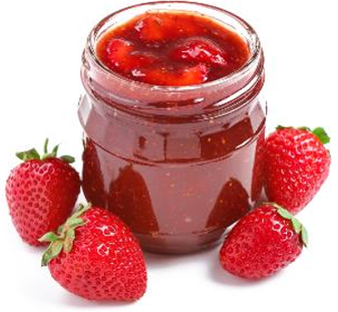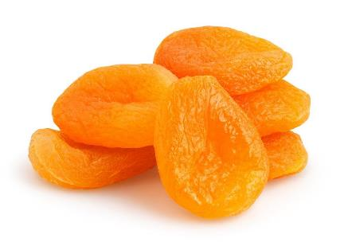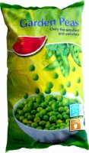

**Tasks**

1. Describe the purpose of food additives. Include at least three examples.
2. Choose a food product and research how it is produced, e.g. frozen fish fingers, chocolate covered biscuits, semi-skimmed milk.

**Hazard analysis, critical control points (HACCP)**Food businesses have a legal responsibility to produce safe food**.**HACCPis a structured approach to risk assessment, used by food companies to make sure they do not break the law by putting consumers at risk.

The seven principles of HACCP are:

|  |  |
| --- | --- |
| 1 | Hazard analysis |
| 2 | Determine the Critical Control Points (CCP) |
| 3 | Establish critical limits |
| 4 | Critical Control Point (CCP) monitoring |
| 5 | Corrective actions |
| 6 | Establish verification procedures |
| 7 | Record keeping procedures |

**Functional foods**

Functional ingredients are ingredients that are specifically included in food for additional health benefits, including pre- and pro- biotics.

**Food processing**

Food processing is any deliberate change in a food that happens before it is available for us to eat; almost all food is processed in some way.

Commercially, the main reasons to process food are to eliminate microorganisms (which may cause disease) and to extend shelf life. Food production and processing ensures that food is edible and safe to eat.  
  
Foods are processed for a number of reasons:

* to extend the shelf life, e.g. making strawberries into jam;
* convenience, e.g. frozen ready meals;
* health, e.g. reduced fat yogurt;
* to provide consumers with more variety and choice;
* to provide additional nutritional benefits, e.g. fortified breakfast cereals.

Jams contain several kinds of additives, including emulsifiers and gelling agents.

**Filling, forming and enrobing**

Many manufactured food products go through a number of processes before they make it to the shop shelves.

**Filling** – a measured quantity of food mixture is injected or sandwiched into the centre of food.

**Forming –** ensures that products are of a uniform shape and size.

**Enrobing –** is a process of coating the outer layer of a product, e.g. chocolate-coated biscuits.

**Extrusion and canning**

**Extrusion** – is a process where raw materials are forced through a cylindrical barrel in order to form, shape and sometimes cook.

**Canning** – aims to destroy all microorganisms and their spores through the application of heat by sterilising food in airtight containers.

**Freezing & dehydrating**   
The shelf life of food and drink can be extended by freezing and dehydrating.

**Freezing** – commercial methods are based on two principles:

1. very low temperatures inhibit growth of microorganisms;

2. the formation of ice crystals draws available water from the food.

**Dehydration** – reduces the water activity level, weight, bulk of the food, and helps to preserve a product. There are a number of techniques used including; sun drying, spray drying, fluidised bed drying, roller drying and accelerated freeze-drying.

For more information, go to:[**https://bit.ly/398qABo**](https://bit.ly/398qABo)

**Packaging**

Due to advances in technology, most food items are now sold pre-packed.  
Food products often have a long journey from the initial manufacturer, until finally being eaten by the consumer. The aim of packaging includes:

* preventing physical damage, e.g. from knocking, shaking or crushing;
* preventing contamination from micro-organisms, pollution or vermin;
* protecting against dehydration or dampness;
* protecting the product’s nutritional and sensory characteristics;
* keeping the product in peak condition;
* helping to increase a product’s shelf life.

Packaging is also designed to be visually stimulating and provide information about the product.

**Food labelling**  
Manufacturers include a range of information on food labels. Some of which is legally required and some of which is useful to the consumer or supermarket. Best-before and use-by dates are examples of information that is legally required.

**New product development (NPD)**

NPD is the process of creating new or modified food products, with the aim of increasing sales to maintain a company’s competitiveness within the consumer market.

NPD involves a complex series of stages, requiring the combined talents of many specialists to make it successful:

* initial ideas;
* test kitchen;
* sensory evaluation;
* pilot plant;
* production specification;
* consumer testing;
* scale up and launch.