**­­­­­­Sensory science**

|  |  |  |  |
| --- | --- | --- | --- |
|  | **Tasting vocabulary (sensory attributes)** | | |
| Sight | Bubbling | Flaky | Opaque |
| Caramelised | Firm | Smooth |
| Clear | Heavy | Solid |
| Coarse | Icy | Steaming |
| Crumbly | Juicy | Sticky |
| Dry | Moist | Thick |
| Smell | Acidic | Fresh | Spicy |
| Aromatic | Meaty | Strong |
| Bland | Mild | Sweet |
| Citrus | Pungent | Tart |
| Earthy | Savoury | Weak |
| Fragrant | Smoky | Zesty |
| Sound | Brittle | Crisp | Pop |
| Crackle | Crunch | Sizzle |
| Taste | Bitter | Rich | Strong |
| Bland | Salty | Sweet |
| Floury | Savoury | Tangy |
| Hot | Smoky | Tart |
| Mild | Sour | Umami |
| Piquant | Spicy | Zesty |
| Touch | Brittle | Dry | Short |
| Bubbly | Gooey | Soft |
| Chewy | Granular | Solid |
| Close | Greasy | Tacky |
| Cloying | Moist | Tender |
| Coarse | Open | Waxy |

**Sensory evaluation and tests**

Sensory evaluation analyses and measures human responses to food and drink, e.g. appearance, touch, odour, texture, temperature and taste. In order to obtain reliable results, sensory evaluation tests should be set up in a controlled way to ensure fair testing, e.g. no distracting colours, noise or smells; same size portions; coded samples, and water to drink.

**Preference tests** - these types of tests supply information about people's likes and dislikes of a product. They are not intended to evaluate specific characteristics, such as crunchiness or smoothness. They are subjective tests and include hedonic, paired comparison and scoring.

**Discrimination tests** - these types of tests aim to evaluate specific attributes, i.e. characteristics of products (crunchiness). They are objective tests and include triangle, duo trio, ranking and paired comparison.

**Using our senses**

A range of senses are used when eating food:

* sight;
* smell;
* hearing;
* taste;
* touch.

A combination of these senses helps to evaluate a food.

**Key terms**

**Fair testing**: Ensuring that sensory tests obtain reliable results.

**Food texture**: The way food is felt by the fingertips, tongue, teeth and palate.

**Olfactory system**: The sensory system used for olfaction, or the sense of smell.

**Senses**: Sight, smell, hearing, taste and touch are all used when eating food and drink.

**Sensory attributes**: Words used to describe the appearance, odour, taste and texture of a food product

**Sensory evaluation**: Analyses and measures human responses to food and drink.

**Appearance**

The size, shape, colour, temperature and surface texture all play an important part in helping to determine first reactions to a food.

**Smell (odour or aroma)**

The nose detects volatile aromas released from food. An odour may be described by association with a particular food, e.g. herby, cheesy, fishy.

The intensity can also be recorded. Odour and taste work together to produce flavour.

**Taste**

There are five basic tastes:

* bitter;
* salt;
* sour;
* sweet;
* umami.

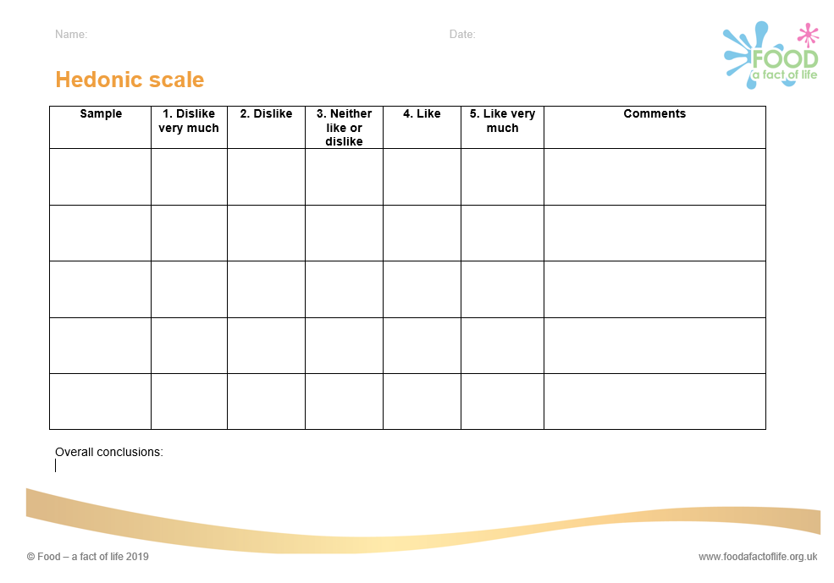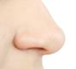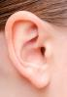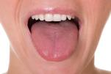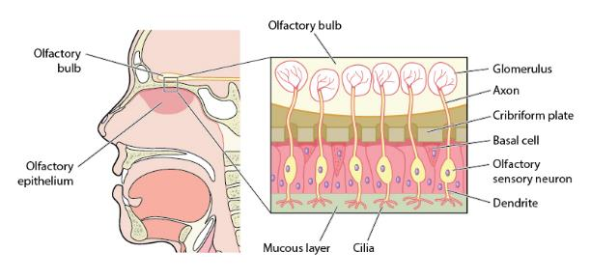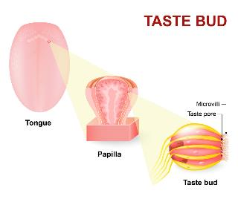

**Touch**

Food texture is the way food is felt by the fingertips, tongue, teeth and palate. When food is placed in the mouth, the surface of the tongue and other sensitive skin reacts to its surface texture. This sensation is known as mouthfeel.

**Hearing (sound)**

The sounds of food being prepared, cooked, served and eaten all help to influence our preferences.The sound of eating food can alter our perception of how fresh a food is, e.g. crunchy carrots.

**Taste receptors**

This is the sensory system used for olfaction, or the sense of smell. As we breathe in, the olfactory receptor cells are stimulated by odours and the olfactory membrane sends neural messages up the olfactory nerve to the brain.

**Olfactory system**

**Tasks**

1. Write a guide to conducting sensory evaluation tests that are fair and reliable.
2. Research umami and make a dish that is rich in the taste of umami.

Our tongues are covered with taste buds, which are designed to sense chemicals in the mouth. Most taste buds are located in the top outer edges of the tongue, but there are also receptors at the back of the tongue as well as on the walls of the mouth and at the back of the throat. As we chew food, molecules mix with saliva, enter taste pores and interact with gustatory hairs, also known as taste receptors. This triggers nerve impulses that are transmitted to the brain.

**Intensity**

Foods may be described by association, e.g. meaty, minty or fruity.

The intensity (low, medium or high) can also be recorded, e.g. garlicky or salty.

To find out more, go to: <https://bit.ly/2Bzsgq5>