**Good food hygiene and safety practices**

Good food hygiene practices are necessary in order to produce, make and supply food that is safe to eat. This involves more than just being clean. A simple way to remember is the **4C**s:

* Cleaning;
* Cooking;
* Chilling;
* Cross-contamination.

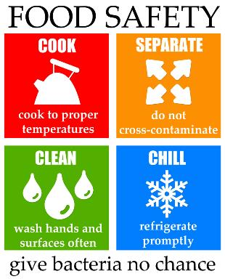

**Key terms**

**Best-before-date:** Relates to the quality of the food. Food may still be eaten beyond this date.

**Cross-contamination**: The transfer of bacteria from one source to another. Usually raw food to ready-to-eat food but can also be the transfer of bacteria from unclean hands, equipment, cloths or pests. Can also relate to allergens.

**Danger zone:** Bacteria will multiply most rapidly between 5-63°C.

**Optimum temperature**: Bacteria that cause food poisoning reproduce around body temperature (37°C).

**The 4Cs:** Cleaning, cooking, chilling and cross-contamination.

**Use-by-date:** Relates to the safety of the food. Food must be eaten by this date.

**Display until Date** – the Shop can only sell the product unto that specified date.

**Cooking**

To reduce the risk of food poisoning, hot food must be served steaming hot, that is above **63ºC**.

* Bacteria will begin to die when the temperature rises above **60ºC**.
* Some foods change colour when they are cooked.
* Cooking food thoroughly to a minimum core temperature of **75°C** will ensure most bacteria is destroyed.
* When cooking burgers, sausages, portions of pork and chicken, there should be no pink meat. They should also be steaming hot inside and the juices should run clear when cooked.
* Steak or other cuts of beef or lamb can be eaten less well done as long as they have been properly sealed. Sealing the meat will kill any bacteria on the outside.
* Leftovers should be cooled as quickly as possible within two hours and then stored in the fridge below **5ºC**. When leftovers are re-heated, they need to be steaming hot. Leftovers should not be re-heated more than once and should be used within 48 hours from when it was made (24 hours for rice dishes).

**Temperatures to remember**

To reduce the risk of food poisoning, good temperature control is vital:



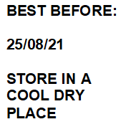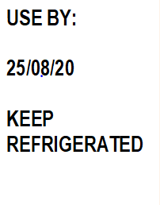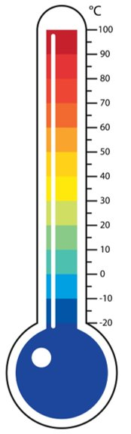

**Safe use of a food probe**

Digital probes can be used to check the temperature of food. To use a food probe:

* Clean with a disinfectant wipe before and after use;
* Insert the probe into the core (centre) or the thickest part of the food;
* Do not touch the bottom of the pan or cooking dish.

**Food labelling**

Food labels help consumers make healthier choices. Some information also helps to reduce the risk of food poisoning or other adverse reactions to food:

* date marks;
* list of ingredients with allergens in **bold**, highlighted, underlined or in *italics*;
* Storage and preparation conditions.

**Tasks**

1. Write a detailed explanation of the 4Cs, demonstrating how they can help to reduce the risk of food poisoning.
2. Explain, giving detailed reasons, the food hygiene controls when buying, preparing, cooking and serving fresh poultry.

For more information, go to: <https://bit.ly/3nE9fpE>

**Cleaning – personal hygiene and getting ready to cook**

Good personal hygiene is essential to reduce the risk of food poisoning.

* **Hands**: Thoroughly wash and dry hands before and after touching food and regularly throughout cooking.
* **Clothing**: Clean clothing should be worn. Long sleeves should be rolled up and a clean apron or chef’s jacket worn over outside clothes. Enclosed, non-slip, shoes should be worn in the kitchen.
* **Jewellery**: All jewellery, including a watch, should be removed (piercings should be covered if they cannot be removed).
* **Skin**: Cuts and wounds should be covered with a coloured, waterproof dressing. The plasters are often blue in colour so they can be easily identified if they fall into food.
* **Face**: Do not cough or spit near or over food, taste food with fingers, bite nails, eat, chew or smoke, touch nose, or remove earrings.

**Cross contamination – raw meat**

* Keep raw meat separate from ready-to-eat food.
* Do not let raw meat drip onto other food.
* Never use the same chopping board for raw meat and ready-to-eat food without washing the board (and knife) thoroughly in between. Ideally use a red board.
* Do not wash meat before cooking it.

**Cleaning**

Cleaning the kitchen is important to keep food safe and prevent bacteria from spreading.

‘Clean as you go’ means people make sure that they clean the area and utensils they have been working in or with, as they prepare food. This avoids build-up of mess and leads to better hygienic conditions. Areas which need particular attention are:

* surfaces that come into contact with food, e.g. chopping boards, utensils;
* surfaces that come into contact with hands, e.g. cupboard and fridge doors.

**Best-before-date**

You can eat food past this date but it might not be at its best quality.

**Use-by-date**

You have until the end of this date to use or freeze the food before it comes too risky to eat.

**Cross-contamination**

The process by which bacteria are transferred from one area to another is known as **cross-contamination**.

The main carriers of bacteria and causes of cross contamination are:

* Humans;
* Rubbish;
* Pests and other animals;
* Food, e.g. raw meat or poultry.

**Chilling**

The temperature between **5ºC– 63ºC** is known as the ‘danger-zone’. Bacteria will multiply most rapidly within this temperature range. Reducing the temperature below **5ºC** slows the reproduction of microorganisms. Cold temperatures do not kill bacteria.

**High-risk food**, such as such as meat, fish and dairy products plus opened bottles, jars or tubes, should be stored below 5°C. Eggs should be stored in a cool, dry place. Ideally, eggs should be stored in the fridge.