**Ingredients – functional characteristics**

* Ingredients are selected for their nutritional, functional and sensory characteristics, as well as provenance and seasonality.

**Food functions**

|  |  |  |
| --- | --- | --- |
|  | Example | What happens? |
| Aerate | Cake | Baking powder makes the cake light |
| Meringue | Egg white is whisked to form a foam |
| Scone | Self-raising flour helps the dough rise |
| Bread | Yeast makes the dough rise |
| Bind | Fish cake | Egg holds other ingredients together |
| Naan bread | Yogurt binds dry ingredients into a smooth dough |
| Pancake | Milk and egg combine flour into batter |
| Pastry | Water combines flour and fat into a dough |
| Bulk | Cottage pie | Texured vegetable protein may be mixed with minced meat and vegetables |
| Fruit pie filling | Sugar is boiled with fruit to form a thick puree |
| Nut roast | Breadcrumbs absorb liquid and increase in size |
| Vegetable samosa | Potato is the main filling |
| Glaze | Hot cross bun | Sugar solution is brushed over bun after baking |
| Gammon | Honey is poured over to glaze |
| Pie | Milk is brushed over before baking |
| Sausage roll | Egg is brushed over to give a shiny golden colour |
| Set | Blancmange | Cornflour is boiled with milk and flavourings and then cooked |
| Cold souffle | Gelatine forms a gel |
| Jam | Pectin mixed with sugar and acid forms a gel |
| Quiche | Egg is mixed with other ingredients and then baked |
| Thicken | Egg custard | Egg thickens when gently heated |
| Sauce flour | Flour thickens a liquid when boiled |
| Soup | Potato thickens soups |
| Syrup | Sugar is boiled with water or fruit juice |

**Dextrinisation**

When food containing starch is heated (without the presence of water) it can produce brown compounds due to dextrinisation. Dextrinisation occurs when the heat breaks the large starch polysaccharides into smaller molecules known as dextrins. Many of these dextrins can also produce a brown colour.

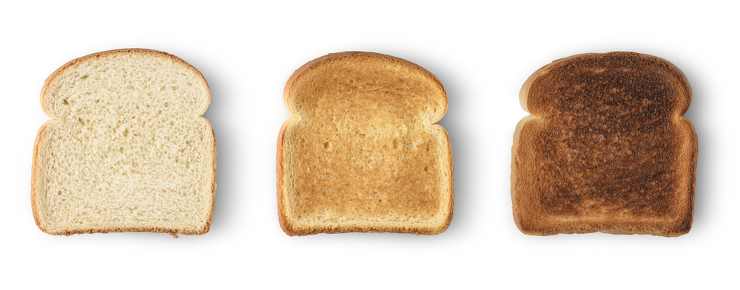

**Selecting ingredients**

Ingredients are chosen for a number of reasons, such as:

* to add flavour, colour or texture;
* to provide a particular function, e.g. to thicken;
* to provide nutrients or change the nutritional profile of a dish, e.g. to increase fibre;
* to extend the shelf life, e.g. vinegar for pickling or chemical preservatives;
* cost and availability, e.g. fruit in season;
* to satisfy a need to buy food with a certain provenance, e.g. Red Tractor.

**Functional characteristics of ingredients**

Ingredients provide a variety of functions in recipes, such as:

* browning, e.g. flour in a bread roll (dextrinisation);
* raising, e.g. yeast in bread (aeration);
* setting, e.g. scrambled eggs (coagulation);
* thickening, e.g. flour in a roux sauce (gelatinisation).

**Adding flavour, colour or texture**

* Fresh and dried herbs and spices can be added to dishes to provide flavour and replace the salt in some dishes, e.g. garlic and ginger.
* Fruit, vegetables, herbs and spices can all be used in recipes to add colour.
* Nuts, seeds, grains, fruit and vegetables can be added to recipes to provide texture.
* The cooking method and cooking time can impact the texture, e.g. steaming or microwaving vegetables quickly can retain their colour, flavour and firm texture.
* Equipment used to process food can impact the texture, e.g. using a food processor to blend soup for a smoother texture.
* Natural, nature identical or artificial additives may be added to foods to perform specific functions.
* The main food additives are antioxidants, colours, flavour enhancers, sweeteners, emulsifiers and stabilizers, andpreservatives.

To find out more, go to: <https://bit.ly/38pu3dt>

**Task**

Explain the function of each of the ingredients in bread, white sauce and Victoria sponge.

**Key terms**

**Aeration**: Incorporating air into a mixture.

**Caramelisation**: The chemical change of heated sucrose (sugar) to caramel, which produces flavour and browning.

**Coagulation**: The irreversible denaturation of protein molecules to thicken and set.

**Denaturation:** A change in the structure of protein molecules, resulting in their unfolding.

**Dextrinisation**: The reaction of dry heat on the surface of food which changes starch to dextrin, e.g. toast.

**Gelatinisation**: The process of thickening which takes place when a mixture of starch and liquid is heated.

**Shortening**: The effect caused when fat is rubbed into flour. The fat coats the flour particles, waterproofing them to prevent gluten formation.

**Raising agents**

These can be:

* mechanical, e.g. beating, creaming, rolling and folding, sieving, whisking;
* chemical, e.g. baking powder, bicarbonate of soda, self-raising flour;
* biological, e.g. yeast.

Different foods may use one or more of these to achieve a desirable end result.

**Tenderisation**

Mechanical tenderisation – a meat cleaver or meat hammer may be used to beat the meat. Cutting into small cubes or mincing can also help.

Chemical tenderisation (marinating)–the addition of any liquid to flavour or soften meat before cooking.

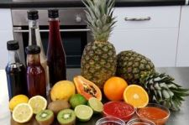

**Maillard reaction**

Foods which are baked, grilled or roasted undergo colour, odour and flavour changes.   
This is primarily due to a group of reactions involving amino acids (from protein) and reducing sugars. This reaction is known as the Maillard reaction. This reaction can also take place in foods with high protein content, such as meat.