**Year 8 Science THB8 – Healthy living Knowledge Organiser**

**Topic 1: Why Cold Weather Can Make You Ill**

* Cold weather does not directly cause illness, but it can weaken the immune system.
* Viruses spread more easily in cold weather as people spend more time indoors.

**Topic 2: Unicellular Organisms**

**Key Knowledge:**

* A unicellular organism is a living thing made up of one cell only.
* Types of unicellular organisms: **bacteria, protozoa, unicellular fungi**.
* Some unicellular organisms are **pathogens** that cause disease.

**Structure of a Bacterium:** 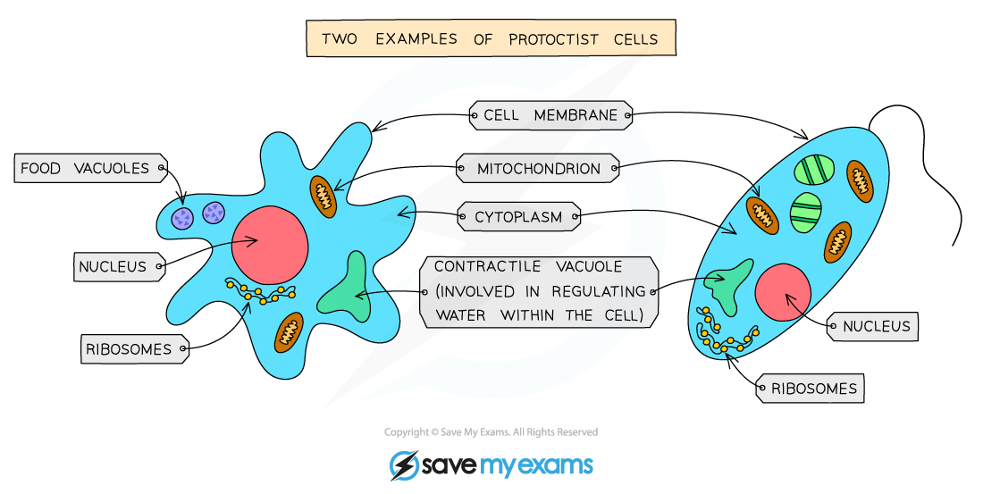

* **DNA** – Controls cell functions.
* **Cytoplasm** – Where chemical reactions happen.
* **Cell Wall** – Provides structure and support.
* **Cell Membrane** – Controls what enters and leaves the cell.
* **Plasmid** – Small DNA loops with extra genes.

**Topic 3: The Effects of Drugs**

**Key Knowledge:**

* A **drug** is a chemical that causes changes in the body.
* Drugs can be **medicinal** (e.g. antibiotics) or **recreational** (e.g. alcohol, nicotine).
* Some recreational drugs are **illegal** and harmful to health.

**Effects of Substance Misuse:**

* Can damage the brain, heart, liver, and other organs.
* Can cause addiction and changes in behaviour.

**Topic 4: The Impact of Exercise, Asthma, and Smoking on Gas Exchange**

**Key Knowledge:**

* **Asthma** affects the airways, making breathing difficult.
* 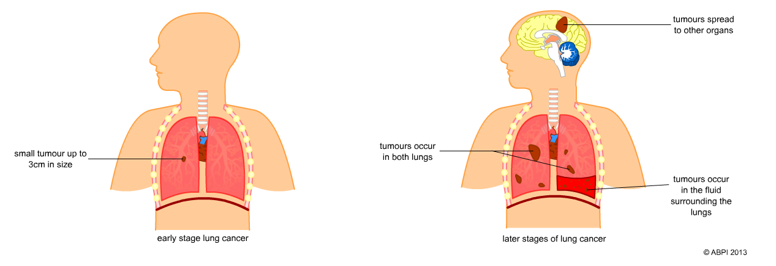**Smoking** damages the lungs and increases the risk of diseases like lung cancer and heart disease.
* **Exercise** increases oxygen demand and improves lung function over time.

**Topic 5: Maternal Lifestyle and the Foetus**

**Key Knowledge:**

* Everything a mother consumes (food, oxygen, drugs) is passed to the baby through the **placenta**.
* 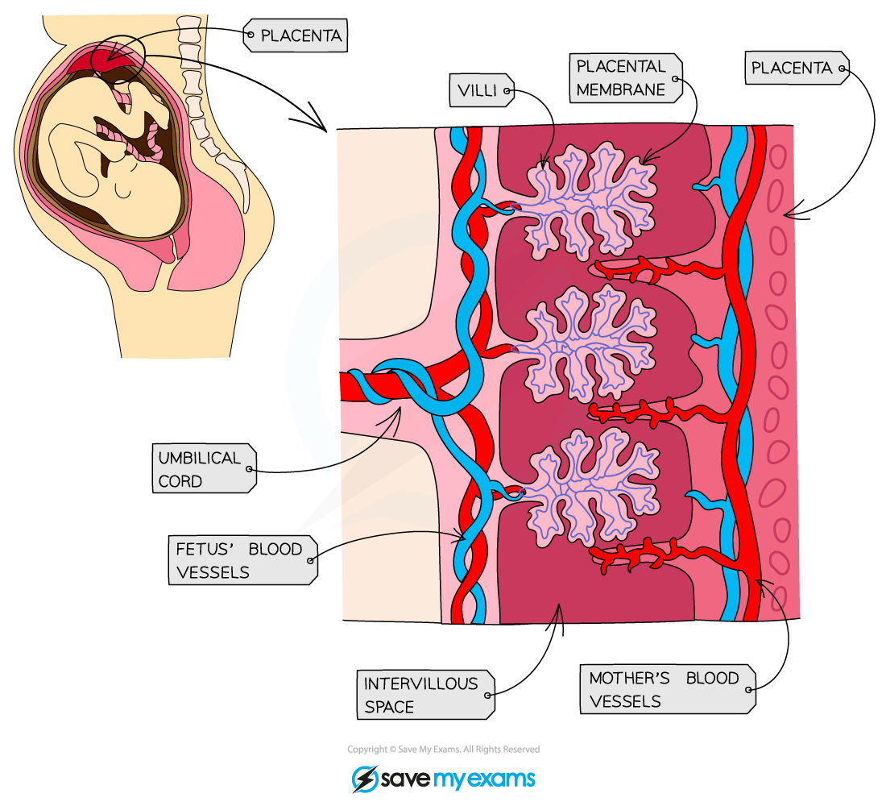
* Smoking, alcohol, and drugs can cause birth defects and affect baby growth.