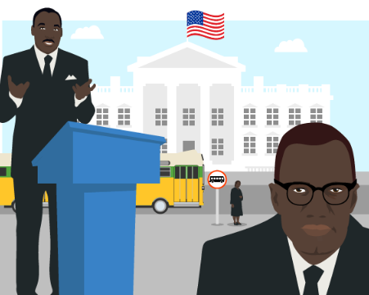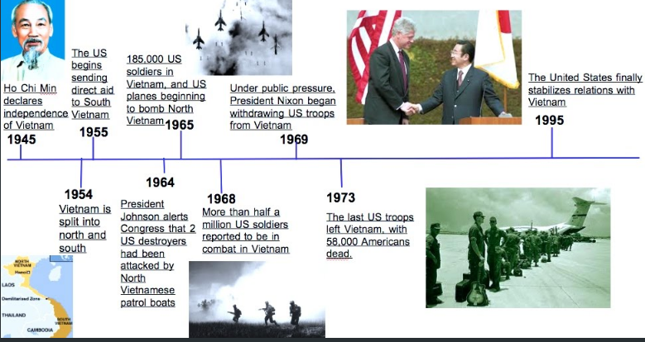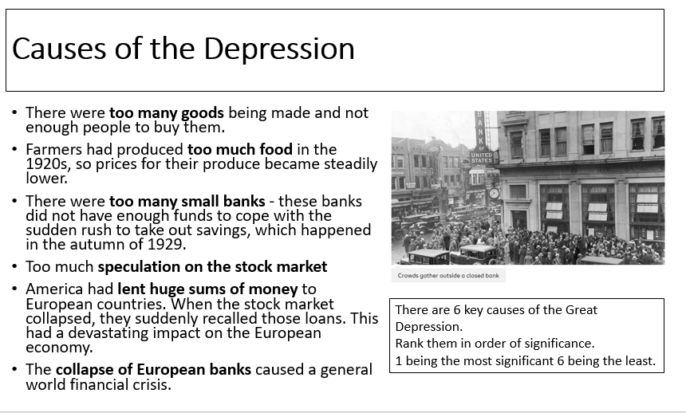

**Civil Rights Movements**

it was in the 1950s and 1960s that the Civil Rights Movement – led by Martin Luther King Jr – challenged white supremacy:

* In 1954, Rev Brown won the right to send his child to a white school. In a huge and unprecedented decision, (Brown v Board of Education, 1954) the Supreme Court finally ruled that segregation could not ever be equal.
* In 1955, Rosa Parks refused to give up her bus seat to a white person, inspiring the Montgomery Bus Boycott.
* In 1957, nine black students, with military protection, went to a white school in Little Rock, Arkansas.
* In 1963, after campaigns of restaurant sit-ins, Freedom Rides on interstate buses and bloody civil rights marches – a quarter of a million people marched to the Lincoln Memorial to hear King's 'I have a dream' speech.

**The Vietnam War**

|  |  |
| --- | --- |
| **Roaring 20’s** | |
| Positives | Problems |
| ***Growing Cities***  In New York, skyscrapers were built because there was no more land available. But even small cities, where land was not in short supply, wanted skyscrapers to announce to the country that they were sharing in the boom.  ***Transport***  The motor car made it possible for more Americans to live in their own houses in the suburbs on the edge of towns. Passenger Aircraft  ***Morals***  Morals changes as sex was more openly discussed- flappers  ***Entertainment***  During the 1920s the entertainment industry blossomed. The average hours worked dropped so people had more time. Wages went up so people had more money to spend on entertainment.  ***Prohibition***  The amount of alcohol drank did drop by 30% in the early 1920s. In fact, in the long-term it could also be seen as a success because the actual consumption of alcohol fell for many years after- it did not reach pre-1914 levels until 1971 | ***Prohibition and gangsters***  Bootleggers (suppliers of illegal alcohol) made vast fortunes and this time saw an increase in the amount of gangsters who organised protection rackets and competed to supply alcohol illegally. Al Capone made around $60 million a year from his speakeasies.  ***Attitudes to immigration***  In 1921 the Republican Party won the election and Warren Harding became President. He set about passing laws that stopped immigration from southern and eastern Europe, Japan and China.  ***KKK***  Racist group that targeted black Americans |