KNOWLEDGE ORGANISER:
The Woman in Black
Core Knowledge

Gothic Conventions
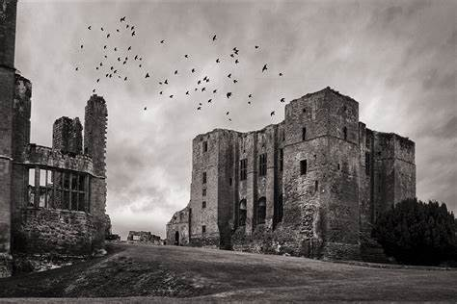
Gothic literature creates an ominous tone and atmosphere using the following conventions:
- An eerie, isolated and dark setting.
- Supernatural beings like ghosts or vampires.
- A plot based around a mystery or secret.
- Melodrama – characters have extreme and exaggerated emotions such as fear and dread.
- Vulnerable women who are distressed because of their circumstances and/or the supernatural.
- Moments of horror, such as violence and death.

Attitudes towards the Supernatural in the Victorian era.
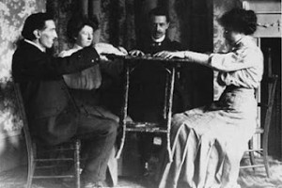
- It was traditional for families to gather around the fire and tell ghost stories on Christmas Eve. This tradition has its roots in the Pagan belief that spirits could walk among us the day before holy events.
- Ghost stories became a way to spend time with family and share moral messages.
- Poorer families who could not afford books shared stories orally.
- As scientific beliefs grew, many people became interested in the supernatural to understand things that traditional scientific methods couldn’t explain.
- Victorian interest in the supernatural was also fuelled by a sense of curiosity, entertainment, and a search for meaning in an industrialised world.

Hill’s Methods

Gothic conventions used in The Woman in Black.
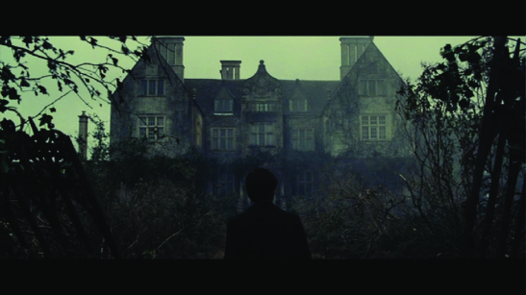
- Setting- Mostly set in Eel Marsh, a remote and isolated house. The house is old, decaying and secretive, cut off by a causeway. It is haunted by the woman in black.
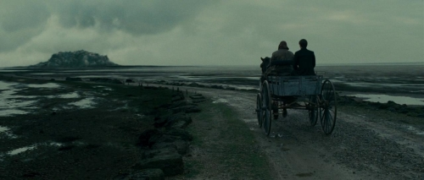
- Supernatural- The woman in black is a ghostly presence that haunts Eel Marsh and haunts the protagonist, Arthur Kipps.
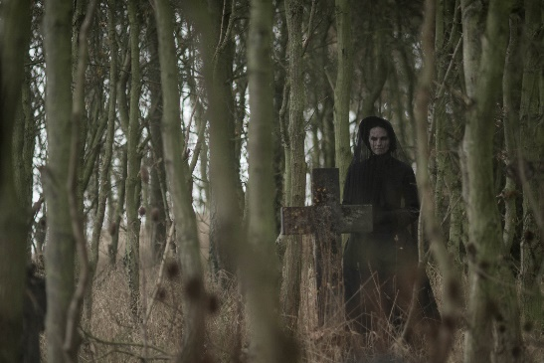
- Horror- Throughout the novel there are lots of moments where the reader feels a sense of horror and fear.
- Mystery- Arthur unwraps the mystery as to why the woman in black haunts Eel Marsh House through reading her letters. Everyone in the town is secretive about her.
- Melodrama- Arthur Kipps’ negative emotional state is heighted when visiting Eel Marsh House, especially at night. He becomes ill from experiencing too much terror. (Arthur Kipps subverts these conventions as he is the distressed victim of a haunting – typically, it would be the female characters acting in this way)
- Women- It is revealed that the woman in black was a victim of the prejudiced beliefs of society towards unmarried mothers. This made her oppressed and vulnerable in life.

Symbols and Motifs
- Light- symbolises safety, hope, knowledge and understanding.
Arthur and the reader feel these when there is light present.
- Darkness- symbolises danger, fear, isolation.
Arthur and the reader feel these when there is darkness present.
- Fog- symbolises ignorance, lack of knowledge or awareness.
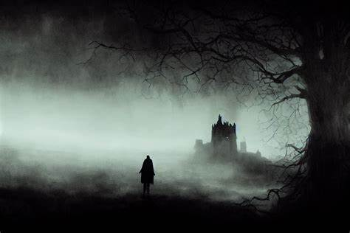
- Birds- act as omens.
They warn Arthur and the reader of upcoming danger.
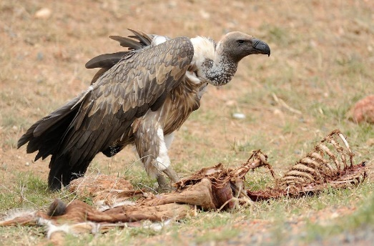
- Fire- symbols emotional warmth, compassion and safety.

Key Vocabulary
Word | Meaning
bleak | Describes an area that is cold and miserable.
convention | A common feature of a type of text.
foreshadowing | When a writer hints about something that happens later in the story.
formative | Describes something that has a big influence on a person’s development.
gothic | Associated with darkness mystery, horror and gloom.
ignorance | A lack of knowledge, awareness or education.
isolated | Far away from other places, buildings or people.
juxtaposition | When a writer places two different things together for a reason.
melodramatic | When someone reacts over the top, or overly emotional.
motif | A symbolic image or idea that is repeated in a text.
narrative voice | The perspective the story is told from.
omen | A symbol or sign used as a warning that something bad is going to happen.
ominous | Giving the impression that something bad is going to happen.
oppression | When power is used cruelly over people and they lose rights or freedom.
pathetic fallacy | When a writer uses the weather to reflect human emotions.
prejudice | An unfair and untrue opinion or belief against a person or group.
protagonist | The main character. They often have heroic characteristics.
sceptical | Doubtful and not easily convinced
superstition | A non-scientific belief in how supernatural things can affect your luck or fate.
symbolism | Something that represents or stands for a bigger idea.
tension | A part of a story that creates emotions such as worry, anxiety, fear and stress.
tone | The mood a writer creates.
trauma | A long-lasting emotional response to something shocking.
vulnerability | The state of being exposed to harm.

