KNOWLEDGE ORGANISER:
Perspectives of War
Core Knowledge

Propaganda and War shown through ‘Who’s for the Game?’ by Jessie Pope.
Propaganda was used through posters, poems, and speeches to influence men to enlist and support the war effort.

Conditioning made men believe it was their duty to fight and that refusing to enlist was shameful or cowardly.

Writers and the media would often trivialise war by making it seem like a game or adventure instead of something dangerous.

Urgency was created by encouraging men to sign up quickly, suggesting they would miss out or let others down if they didn’t.
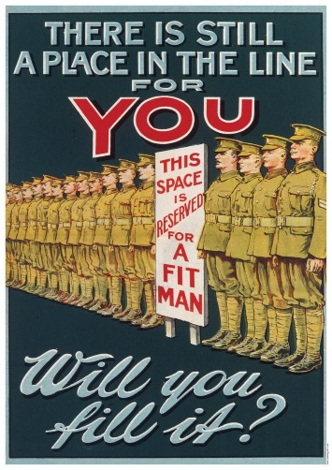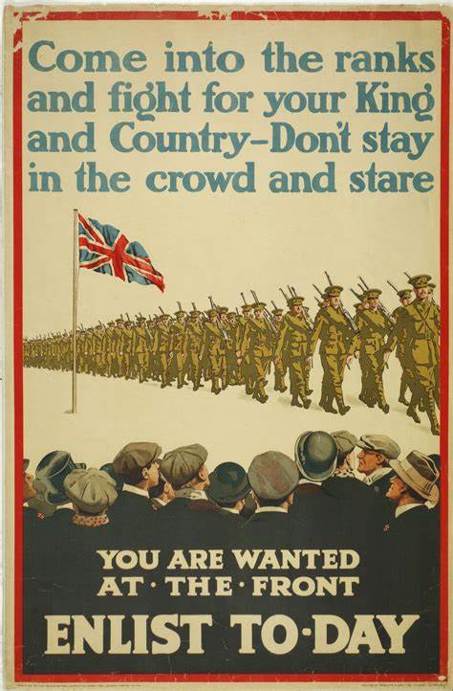

Poets and Rebellion shown through ‘To Whom it May Concern’ by Adrian Mitchell.
- Poets often take back their agency by using their writing to speak truths that governments or the media may try to hide, especially about the realities of war.
- Their work serves as a powerful critique of propaganda, challenging the idea that war creates honour.
- By showing the emotional and physical suffering caused by war, poets confront the ignorance that allows people to accept war without questioning it.

The Mental Effects of War shown through ‘Remains’ by Simon Armitage.
- War often strips soldiers of their agency, as they are forced to follow orders and witness horrors they cannot control or prevent.
- Many experience long-lasting trauma, including nightmares and guilt, which can affect them for years after the war ends.
- To survive mentally, some become desensitised—they shut down their emotions or detach from violence, which can make it hard to reconnect with everyday life.

Poets and the Reality of War shown through ‘Dulce et Decorum est’ by Wilfred Owen.
- War poets often write as a critique of propaganda, challenging ideas that trivialise war or hide its harsh truths.
- They express feelings of disillusionment, showing how soldiers lose faith in the honourable image of war they were made to believe.
- By describing the brutality of combat—violence, death, and suffering—they reveal what war is really like.
- Their work shows how war can dehumanise soldiers and enemies, reducing people to bodies or targets instead of human beings.
- Some poets question the idea of duty, exploring how it can be used to pressure individuals into fighting without thinking about the true cost.

How War Affects the World shown through ‘War Photograph’ by Kate Daniels and ‘Lament’ by Gillian Clarke’
- War often takes away the autonomy of innocent people, leaving them powerless as their lives are disrupted or destroyed by forces beyond their control.
- Civilians face the brutality of war through bombings, destruction, and sudden loss—despite not being part of the fighting themselves.
- Civilians, especially children, are placed in extreme vulnerability, often placed in dangerous situations without protection.
- War creates a clear disparity between those in power and the ordinary public, who suffer the most while having little say in the decisions that lead to war.
- War causes severe damage to the environment, destroying landscapes, polluting water and air, and wiping out ecosystems that may take decades to recover.
- This environmental destruction leads to deprivation, as people lose access to clean resources like food, water, and shelter.
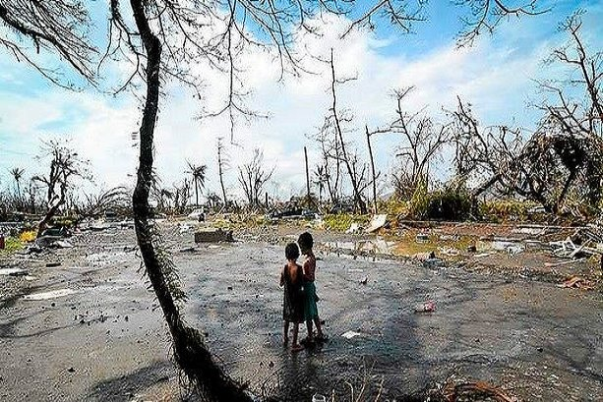

Poets and the Effects of War
- Poets often write with a sense of urgency, trying to raise awareness and inspire action before more damage is done.
- Their work highlights the vulnerability of both people and the planet, showing how war leaves nature and civilians equally exposed to harm.
- By describing the brutality of war beyond the battlefield—through scorched earth, poisoned soil, and ruined cities—they reveal its full impact.
- Some poems show how the effects of war are inescapable, spreading far beyond the front lines and leaving lasting scars on the earth itself.

Poetic Structure

Rhyme | Rhyme: When lines in a poem end with words that sound the same, usually following a regular pattern (like AABB or ABAB).  How it's usually used:  - Rhyme can make a poem sound controlled, ordered, and even persuasive.  - It can feel predictable and steady, which sometimes hides uncomfortable truths (like in propaganda poems).  - Sometimes it's used to give a poem a sense of comfort or tradition.  Link to control:  Poets use rhyme to keep tight control over the reader’s emotions, or to show how a speaker (or society) is trying to control the message—often to make war sound brave or simple.
Lack of Rhyme | Lack of rhyme: When a poem doesn’t have a regular rhyme scheme.  How it's usually used:  - It can reflect freedom, chaos, or emotional honesty.  - It’s often used when a poet wants the speaker’s feelings to sound real and unfiltered.  - It lets the poet break the rules on purpose—often to express pain, anger, or protest.  Link to control:  When poets don’t use rhyme, they might be rejecting control, showing that the speaker has lost control, or challenging the control of society or power. It often mirrors how messy and emotional war really is.
Enjambment | Enjambment: When a sentence or phrase carries on from one line to the next without a pause. (The opposite is when a line ends with a full stop or comma.)  How it's usually used:  - Enjambment keeps the poem flowing, which can build tension or make things feel rushed or out of breath.  - It can show confusion, lack of control, or overwhelming emotion.  - It’s often used in poems about war or trauma to mirror how thoughts and memories won’t stop.  Link to control:  Enjambment often shows the speaker is struggling to stay in control, or that the poet wants the reader to feel overwhelmed—just like the speaker does.
Caesura | Caesura: A pause or break in the middle of a line, usually marked by punctuation (e.g. dash, comma, full stop).  How it's usually used:  - Caesura can show sudden emotion, shock, or a break in thought.  - It’s used to make the reader stop and feel the impact of a moment.  - It can show that is struggling with something painful or hard to say.  Link to control:  Caesura often shows how control is breaking down—the speaker can’t keep their thoughts or emotions steady. Or it may show the poet is taking control over rhythm to force the reader to pause and think.

Key Vocabulary
Word | Meaning
agency | The ability to make your own choices.
autonomy | Being independent and making your own decisions.
brutality | Extreme cruelty or violence.
caesura | A pause in the middle of a line of poetry, usually shown with punctuation like a comma or dash.
conditioning | How people learn and view things based on their experience of society.
critique | A judgement or criticism of something.
dehumanise | To treat someone as if they are less than human.
deprivation | When someone doesn’t have something they need, usually because it is taken away from them.
desensitised | When someone is less likely to feel shocked by a situation because they have seen it so many times.
desperation | Needing or wanting something very much.
disillusionment | The feeling you get when you realise something isn’t as good or true as you thought.
disparity | A big difference between two things, especially in the way people are treated or what they have.
duty | A responsibility to do something.
enjambment | When a sentence continues after the end of a line in a poem, with no punctuation at the end of the line.
honour | Reputation and respect for doing the right thing.
ignorance | A lack of knowledge, awareness or education.
inescapable | Unable to be avoided.
propaganda | Information (usually false) which is spread to promote a cause.
rhyme | When lines end with words that sound the same (often in a pattern like AABB or ABAB).
severe | Describes something very strict or harsh.
trauma | A long-lasting emotional response to something shocking.
trivialise | To make something seem less important than it really is.
urgency | The need to act quickly.
vulnerability | The state of being easily harmed.

