**Impact of WW2 on Britain**

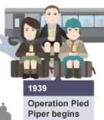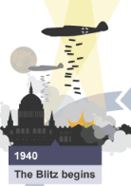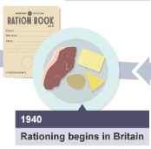

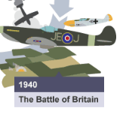

**Blitzkrieg-Lightning War- using all your forces at once to take over a country**

**Blitz- Lightning**

Key Dictators

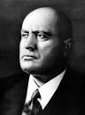**Mussolini**

In 1925 became the dictator of Italy

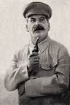**Stalin**

In 1926 Stalin became the dictator of Russia

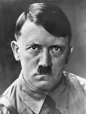**Hitler**

In 1934 became the dictator of Germany

**Why did the allies win WW2?**

**Technology**

**Tactics**

**Leadership**

**Luck**

|  |  |
| --- | --- |
| Outbreak of War | 1 September 1939 Germany invades Poland using Blitzkrieg. As a result Britain declares war on Germany. |
| Dunkirk  Spring 1940 | In 1940 the British army was pushed back by the German army to a tiny area in France called Dunkirk. The British troops were trapped between the German army and the English Channel & needed evacuating. 340,000 soldiers were evacuated back to England |
| Battle of Britain  June-October 1940 | Hitler ordered the Luftwaffe (German air force) to increase air attacks on towns, ports and air bases to ‘take out’ the RAF. The RAF responded by sending planes to fight. Every day between June and October 1940 there were clashes and dogfights between German and British planes. |
| The Blitz  1940-41 | The Blitz was a German bombing campaign against the United Kingdom in 1940 and 1941, during the Second World War. |
| The Battle of Stalingrad  Winter 1942-43 | The German commander of the Sixth Army, General Paulus, advanced on the city of Stalingrad- it was a crucial communication centre for Russia and centre of manufacturing. His primary task was to secure the oil fields in the Caucasus and to do this, Paulus was ordered by Hitler to take Stalingrad. The Russian army had 187,000 men but Germany had 270,000 men. The Germans took a great deal of the city but they failed to fully assert their authority. Temperatures dropped to well below zero and food, ammunition and heat were in short supply. However, by the end of January 1943, the Germans could do nothing else but surrender. |
| D-Day Landings  1944 | Attack on Normandy to reach the Nazis. The attack began when Allied planes and warships bombarded German positions along the coastline. This was to damage the defences making it easier for the troops to get ashore. At the same time, planes and gliders dropped tens of thousands of allied soldiers behind the German defences. They took control of important roads and bridges. This made it harder for the German army to rush extra men towards areas where the troops were landing. |
| Dresden Bombings  1945 | Allied forces bombed the historic city of Dresden, located in eastern Germany. Civilian target—estimated at somewhere between 35,000 and 135,000–were dead. |
| Death of Hitler  30 April 1945 | Hitler committed suicide in his underground bunker in Berlin as the Russian forces (Red Army) were approaching the capital. |
| VE Day  8 May 1945 | Victory in Europe Day |